Министерство науки и высшего образования Российской Федерации
НАЦИОНАЛЬНЫЙ ИССЛЕДОВАТЕЛЬСКИЙ
ТОМСКИЙ ГОСУДАРСТВЕННЫЙ УНИВЕРСИТЕТ (ТГУ)
Институт прикладной математики и компьютерных наук

ДОПУСТИТЬ К ЗАЩИТЕ В ГЭК
Руководитель ОПОП
д-р техн. наук, профессор
____________ А.В. Замятин
«_____»____________2026 г.

ВЫПУСКНАЯ КВАЛИФИКАЦИОННАЯ РАБОТА МАГИСТРА

(МАГИСТЕРСКАЯ ДИССЕРТАЦИЯ)

A METHOD FOR STUDYING TIME SEQUENCES OF CLINICAL INDICATORS OF INTENSIVE CARE PATIENTS USING SHAPLEY VALUES

по направлению подготовки 01.04.02 Прикладная математика и информатика,
направленность (профиль) «Big Data and Data Science»

Naqvi Syed Ihsaan Abbas

Научный руководитель ВКР
канд. техн. наук
____________С.В. Аксёнов
«_____»____________2026 г.

Автор работы
студент группы № 932430
____________S. I. A. Naqvi
«_____»____________2026 г.

Томск – 2026
Министерство науки и высшего образования Российской Федерации.
НАЦИОНАЛЬНЫЙ ИССЛЕДОВАТЕЛЬСКИЙ
ТОМСКИЙ ГОСУДАРСТВЕННЫЙ УНИВЕРСИТЕТ (НИ ТГУ)
Институт прикладной математики и компьютерных наук

УТВЕРЖДАЮ
Руководитель ОПОП
д-р техн. наук, профессор

______________ А.В. Замятин
подпись
«_____»_______________ 20___ г.
ЗАДАНИЕ
по выполнению выпускной квалификационной работы магистра обучающемуся
Naqvi Syed Ihsaan Abbas
Фамилия Имя Отчество обучающегося
по направлению подготовки 01.04.02 Прикладная математика и информатика, направленность (профиль) «Big Data and Data Science»
1 Тема выпускной квалификационной работы
A method for studying time sequences of clinical indicators of intensive care patients using
Shapley values
2 Срок сдачи обучающимся выполненной выпускной квалификационной работы:
а) в учебный офис / деканат – |  | б) в ГЭК –
3 Исходные данные к работе:
Объект исследования – |  | In-hospital mortality of intensive care unit patients, modelled from
 |  | the first 48 hours of physiological monitoring (PhysioNet/CinC
 |  | Challenge 2012, Set-A; 4000 patients).
Предмет исследования – |  |  | Machine-learning methods for early mortality prediction and
 |  |  | their post-hoc explanation by time-step SHAP attribution on
 |  |  | multivariate clinical time series.
Цель исследования – | To develop, evaluate, and explain a deep-learning model for early in-hospital mortality prediction on the PhysioNet 2012 Set-A cohort
Задачи:
1. Pre-process the 4000-patient cohort into a uniform (4000, 48, 37) tensor while
preserving measurement-timing information.
2. Train and evaluate three model families (XGBoost, TCN, Time-Aware Transformer) under
an identical protocol and the official Challenge metrics.
3. Develop a time-step SHAP attribution procedure mapping variable-level Shapley values
onto the (patient, hour, variable) coordinate system.
4. Validate the clinical plausibility of the attributions against SOFA and SAPS-I component
variables on a per-patient basis.
5. Conduct an ablation study to identify the architectural and loss-function choices that
contribute most to performance.
Методы исследования:
Hourly median aggregation with explicit missingness-mask encoding; gradient-boosted
decision trees (XGBoost) on engineered temporal features; a dilated causal temporal
convolutional network; a Time-Aware Transformer with learnable positional encoding trained
under focal loss; TreeSHAP with proportional time-step redistribution; Spearman correlation
analysis for clinical validation; and a controlled ablation study.
Организация или отрасль, по тематике которой выполняется работа, –
Healthcare; critical-care (intensive-care) medicine and clinical machine learning
4 Краткое содержание работы
Chapter 1 reviews ICU severity scoring, deep learning for clinical time series, and explainable
artificial intelligence.
Chapter 2 describes the data, pre-processing, the three model families, the time-step SHAP
procedure, and the clinical-validation protocol.
Chapter 3 reports the comparative performance, the ablation analysis, the attribution case
studies, and the SHAP–severity-score concordance test. The Conclusion summarises the
findings and outlines external-validation and counterfactual extensions.

Научный руководитель выпускной
квалификационной работы
PhD (Tech. Sciences), National Research Tomsk State University |  | _______________ / | S.V. Axynov
должность, место работы |  | подпись | И.О. Фамилия
Задание принял к исполнению
Student, group №. 932430 |  | _______________ / | S. I. A. Naqvi
должность, место работы |  | подпись | И.О. Фамилия

ABSTRACT
Naqvi I. A method for studying time sequences of clinical indicators of intensive care patients using Shapley values Approach on the PhysioNet 2012 Challenge Dataset. – Master’s thesis. – Tomsk: TSU, 2026. – 96 p.
The thesis develops a mechanism for predicting in-hospital mortality among intensive care unit patients from the physiological parameters measured in the first forty-eight hours of admission and, just as importantly, for interpreting those predictions in terms a clinician can interrogate. The work uses Set-A of the PhysioNet/Computing in Cardiology Challenge 2012 dataset, which comprises four thousand adult patient records drawn from medical, surgical, coronary, and cardiac-surgery units. After pre-processing, the cohort exhibits an in-hospital mortality rate of 13.5 per cent, which makes the task a strongly imbalanced binary classification problem.
Three model families are evaluated through a single shared pre-processing pipeline applied to identical inputs: a gradient-boosted decision-tree model (XGBoost) trained on 227 hand-crafted temporal features; a Temporal Convolutional Network (TCN) with dilated, causal convolutions; and a Time-Aware Transformer with learnable sinusoidal positional encodings and a 74-channel input made of 37 physiological variables and 37 binary masks marking their presence. All three models are trained and tested on the same 2800/600/600 patient split and measured against the official Challenge metrics: Event 1 (Score1 = min(Sensitivity, Positive Predictivity) at the best probability threshold) and Event 2 (the Hosmer–Lemeshow H statistic). XGBoost attains AUROC = 0.8798, Score1 = 0.5422, and HL-H = 37.67; the Transformer attains AUROC = 0.8542 and Score1 = 0.5301. Both substantially exceed the official SAPS-I baseline (Score1 = 0.3097).
The principal scientific contribution is an algorithm for computing SHAP values at the level of each individual time step. The conventional SHAP estimator returns one value per flattened feature and therefore discards the temporal structure of a sequence input. Here, SHAP values are first computed on the 227-dimensional flat feature vector and then redistributed to each of the forty-eight hourly slices in proportion to the absolute observed value at that hour, yielding a 600 × 48 × 37 attribution tensor expressed in the same coordinates as the raw input. This allows questions such as “which hour of which variable mattered most for this patient” to be answered without any special-purpose model.
The clinical validity of the attributions is assessed using per-patient concordance with two widely used severity scales as a reference. The Spearman correlation between SHAP–SAPS-I concordance and patient-level calibration error is significantly different from zero (ρ = 0.139, p = 6.3 × 10⁻⁴), and the mean SAPS-I concordance is 0.498 (std 0.156), indicating that the model assigns relevance to variables clinicians already use for prognosis. An ablation study examines the impact of each design decision: removing the missingness channels lowers Score1 by 6.6 points and severely damages calibration, and the encoding of measurement timing emerges as the single most informative architectural element.
The thesis closes with its limitations (single-centre, retrospective analysis; attribution versus causation) and with directions for future work (prospective validation on MIMIC-IV and eICU cohorts).
Keywords: intensive care, in-hospital mortality, PhysioNet 2012 Challenge, explainable artificial intelligence, SHAP, Transformer neural network, time-series classification, missingness, clinical decision support.

CONTENTS
LIST OF ABBREVIATIONS AND SYMBOLS 3
INTRODUCTION 4
1 Literature review 9
1.1 Mortality prediction in the intensive care unit 9
1.2 Machine learning on ICU time series 11
1.3 Explainable artificial intelligence 13
1.4 Synthesis and position of this work 16
2 Methodology and data 18
2.1 Dataset 18
2.2 Pre-processing 18
2.3 Model family I – XGBoost on engineered features 21
2.4 Model family II – Temporal Convolutional Network 21
2.5 Model family III – Time-Aware Transformer 22
2.6 Time-step SHAP attribution 24
2.7 Clinical validation against SOFA and SAPS-I 26
2.8 Ablation study 27
2.9 Evaluation metrics 27
2.10 Implementation and reproducibility 28
3 Results, findings and discussion 29
3.1 Comparative performance on Set-A 29
3.2 Discrimination versus calibration 32
3.3 Time-step SHAP – global findings 35
3.4 Patient-level case studies 37
3.5 Attention head specialisation 38
3.6 Ablation study 39
3.7 Clinical validation: SHAP–SOFA / SAPS-I concordance 40
3.8 Limitations and threats to validity 43
CONCLUSION 45
REFERENCES 50
APPENDIX A Variable list 55
APPENDIX B Full ablation table 57
APPENDIX C Hyperparameters of the three model families 58
APPENDIX D Reproducibility checklist 60

LIST OF ABBREVIATIONS AND SYMBOLS
APACHE – Acute Physiology and Chronic Health Evaluation
AUPRC – Area Under the Precision–Recall Curve
AUROC – Area Under the Receiver Operating Characteristic Curve
BCE – Binary Cross-Entropy
BUN – Blood Urea Nitrogen
CLS – Classification (token)
EHR – Electronic Health Record
GCS – Glasgow Coma Scale
HL-H – Hosmer–Lemeshow H statistic
ICU – Intensive Care Unit
MAP – Mean Arterial Pressure
MLP – Multi-Layer Perceptron
SAPS – Simplified Acute Physiology Score
SHAP – SHapley Additive exPlanations
SOFA – Sequential Organ Failure Assessment
TAPE – Time-Aware Positional Encoding
TCN – Temporal Convolutional Network
XAI – Explainable Artificial Intelligence

INTRODUCTION
Background and motivation
Intensive care units consume between thirteen and twenty per cent of total inpatient hospital costs in high-income health systems while caring for under ten per cent of admitted patients [Halpern & Pastores, 2010]. The disproportion is driven by the density of monitoring and the irreversibility of many treatment decisions: a delayed escalation to mechanical ventilation, a missed early indication of septic shock, or an inappropriate transfer from a step-down unit each carry mortality consequences that surgical or pharmacological intervention cannot later undo. Risk stratification – the act of estimating, from measurements taken in the first hours of admission, how likely a given patient is to die before hospital discharge – has therefore been a central problem of critical-care medicine since the introduction of APACHE I in 1981 [Knaus et al., 1981]. Successive generations of severity scores (APACHE II/III/IV, SAPS I/II/3, SOFA, MPM) have refined the regression weights, expanded the variable lists, and recalibrated to changing case mixes, yet all of them share two assumptions that modern data make untenable. First, they collapse the first twenty-four hours into a single worst-value summary, discarding the trajectory information that bedside clinicians act upon. Second, they treat missing observations as missing-at-random, even though it is well established that what is not measured in an ICU is a function of clinical judgement and therefore informative [Sharafoddini et al., 2019].
The widespread deployment of high-frequency clinical data warehouses since approximately 2010 – MIMIC-III/IV at Beth Israel Deaconess, eICU-CRD across the Philips network, AmsterdamUMCdb in the Netherlands, and the PhysioNet/Computing in Cardiology Challenge corpora – has made it feasible to train far more flexible models. Deep-learning architectures originally developed for natural-language processing (recurrent networks, temporal convolutional networks, Transformers) translate naturally to multivariate clinical time series, and have repeatedly been shown to outperform classical severity scores under area-under-the-curve metrics by five to ten percentage points [Shickel et al., 2018; Rajkomar et al., 2018; Sheikhalishahi et al., 2020]. Yet adoption at the bedside has been slow. The reason is not metric performance but trust: a Transformer that emits a probability of 0.74 without explaining why offers the attending physician nothing they can argue with on a ward round, nothing they can defend in a morbidity-and-mortality conference, and nothing they can correct if the model has latched onto a confounding artefact of the unit’s documentation habits.
Explainable artificial intelligence (XAI) is the response to this trust gap. The two methods that have come to dominate the post-hoc explanation literature are LIME [Ribeiro et al., 2016] and SHAP [Lundberg & Lee, 2017]. SHAP, which extends Shapley values from cooperative game theory to feature attribution, has particularly desirable theoretical properties – local accuracy, missingness, consistency – that make its outputs admissible as the basis for clinical reasoning. In its standard form, however, SHAP returns one attribution per input feature, which is appropriate for tabular data but loses essential information when the input is a multivariate trajectory: knowing that “heart rate matters” is far less useful to a clinician than knowing that “the heart-rate excursion between hour 14 and hour 19 mattered.” Reconstructing the temporal axis from a model trained on flattened features is the methodological problem that this thesis addresses.
Research problem
Two related problems are studied:
1. Modelling problem. Construct a predictor of in-hospital mortality from the first forty-eight hours of ICU monitoring on PhysioNet 2012 Set-A that matches or surpasses both classical severity scores and recent deep-learning baselines on the official Event 1 (discrimination at the optimal operating point) and Event 2 (calibration) metrics, while respecting the imbalanced (≈13.5 % positive) nature of the cohort.
2. Explanation problem. Produce, for each individual prediction, an attribution map of shape (time × variable) that identifies the specific hourly bins of the specific physiological variables driving the model’s risk estimate, and demonstrate that those attributions are clinically meaningful – that they agree, on average, with the variables that established severity scores (SOFA, SAPS-I) draw upon for the same patient.
Research questions
The thesis is organised around four questions:
RQ1. Can a model that explicitly encodes missingness as a parallel channel of binary masks outperform an identically configured model that imputes missing values silently?
RQ2. Does a Time-Aware Transformer architecture, in which positional encodings are learnable rather than fixed, achieve discrimination comparable to a heavily feature-engineered gradient-boosted tree model on this dataset?
RQ3. How can a SHAP explanation computed on a flat feature vector be redistributed onto the (time × variable) coordinate system in a way that preserves the total attribution and reflects the temporal incidence of evidence?
RQ4. Do the resulting per-patient attribution maps agree with the variables that established clinical severity scores (SOFA, SAPS-I) emphasise for the same patient?
Aim and objectives
The aim of the thesis is to develop, evaluate, and explain a deep-learning model for early in-hospital mortality prediction on PhysioNet 2012 Set-A. The aim decomposes into the following objectives:
1. Pre-process the 4000-patient cohort into a uniformly shaped (4000, 48, 37) tensor while preserving information about when each measurement was taken.
2. Train and evaluate three model families – XGBoost, TCN, Time-Aware Transformer – under an identical experimental protocol and on the official Challenge metrics.
3. Develop a time-step SHAP attribution procedure that maps variable-level Shapley values onto the (patient, hour, variable) coordinate system.
4. Validate the clinical plausibility of the resulting attributions by comparing them against SOFA and SAPS-I component variables on a per-patient basis.
5. Conduct an ablation study to identify which architectural and loss-function choices contribute most to performance.
Scientific novelty
Three contributions distinguish this work from the existing literature:
Time-step SHAP redistribution. The procedure described in Chapter 2 computes Shapley values on a flattened feature vector and then redistributes each value across the corresponding temporal trajectory in proportion to the absolute observed values, producing an attribution tensor of the same shape as the raw input. The construction preserves the local-accuracy property of SHAP at the variable level while restoring the temporal axis. The redistribution is exact when the observed trajectory contains a single non-zero value and degrades gracefully when measurements are uniformly distributed.
Quantitative clinical validation of post-hoc explanations. Rather than presenting attribution maps as a qualitative illustration, the thesis defines a per-patient concordance score against SOFA and SAPS-I component variables and tests, via Spearman correlation between concordance and calibration error, whether patients for whom the model “agrees with the clinical scores” are also patients for whom the model is better calibrated. The hypothesis is supported (ρ = 0.139, p = 6.3 × 10⁻⁴ for SAPS-I), providing one of the few statistically tested clinical-plausibility results in the SHAP-for-ICU literature.
Ablation isolating informative missingness. The ablation table in Chapter 3 isolates four variants of the Transformer and shows that removing the missingness-mask channels degrades Score1 by 6.6 points and the Hosmer–Lemeshow statistic by more than 140 units. This quantifies the contribution of informative missingness on PhysioNet 2012 with a level of precision absent from the published literature on this corpus.
Significance
On the engineering side, the thesis provides a reproducible pipeline (227-feature XGBoost, dilated TCN, 205 k-parameter Transformer) calibrated to a public benchmark, with all hyperparameters and training seeds disclosed. On the clinical side, it offers a per-patient explanation tool whose output lives in a coordinate system clinicians already inhabit – hours since admission × physiological variable – rather than a coordinate system imposed by the model.
Structure of the thesis
The remainder of the thesis is organised as follows. Chapter 1 surveys the literature on severity scoring, deep learning for ICU prediction, and explainable artificial intelligence. Chapter 2 details the dataset, pre-processing, model architectures, the time-step SHAP procedure, and the clinical-validation protocol. Chapter 3 presents the comparative results, the ablation analysis, the attribution case studies, and discusses what the experiments do and do not show. The Conclusion summarises the contributions and points to extensions on MIMIC-IV. Appendices contain the variable list, the full ablation table, the hyperparameters, and the reproducibility checklist.

1 Literature review
This chapter situates the thesis at the intersection of three established research traditions: classical severity scoring in critical-care medicine, machine-learning approaches to clinical time series, and the still-maturing field of explainable artificial intelligence (XAI). The aim is not encyclopaedic coverage but enough orientation for a reader who is comfortable with one of these traditions to understand the contributions of the other two and to see why their combination is non-trivial.

1.1 Mortality prediction in the intensive care unit

1.1.1 The clinical problem
An adult patient admitted to an intensive care unit in a contemporary tertiary hospital generates, conservatively, tens of thousands of measurements in the first day: bedside monitors sample heart rate, blood pressure, oxygen saturation, and respiratory rate at the minute scale; the laboratory returns dozens of chemistry and haematology panels; nurses chart fluid balance, sedation level, and Glasgow Coma Scale hourly. From this torrent the attending intensivist must construct, by the end of the morning ward round, a working estimate of how sick the patient is, how that compares to other patients on the unit, and which interventions will most reduce the conditional probability of in-hospital death. Severity scores formalise the first two operations.

1.1.2 The APACHE family
The Acute Physiology and Chronic Health Evaluation (APACHE) system, introduced by Knaus and colleagues in 1981 [Knaus et al., 1981], assigned weights to the worst values of twelve physiological variables in the first twenty-four hours, added points for chronic-health status and age, and predicted hospital mortality through a logistic regression calibrated on a cohort of approximately 800 patients. Successive revisions – APACHE II (1985), APACHE III (1991), APACHE IV (2006) – expanded the variable list, recalibrated the regression coefficients to changing case mixes, and incorporated diagnosis-specific terms. The most recent version, APACHE IV, achieves area under the receiver operating characteristic curve (AUROC) of approximately 0.88 on the cohort of 110 000 admissions on which it was developed [Zimmerman et al., 2006], although external-validation studies typically report values in the 0.80–0.85 range.

1.1.3 The SAPS family
The Simplified Acute Physiology Score, developed in parallel by Le Gall and colleagues in France [Le Gall et al., 1984; 1993; 2005], pursued the same goal with a smaller variable list. SAPS-I uses fourteen variables and is the score originally embedded in the PhysioNet 2012 Challenge as a baseline. SAPS-II uses seventeen variables and was for many years the most widely deployed score in Europe. SAPS-3 abandons the worst-value-in-24-hours convention in favour of admission-time variables only, on the argument that one of the points of a severity score is to be available before treatment effects confound the prediction.

1.1.4 SOFA
The Sequential Organ Failure Assessment score, introduced at a 1994 European Society of Intensive Care Medicine consensus conference and formalised by Vincent and colleagues [Vincent et al., 1996], differs in purpose from APACHE and SAPS. It is a dynamic score: each of six organ systems (respiratory, coagulation, hepatic, cardiovascular, central nervous system, renal) is assigned an integer 0–4, and the score is recomputed daily. It was not designed as a mortality predictor but has been widely repurposed as one. SOFA remains the score embedded in the consensus definition of sepsis [Singer et al., 2016]. The thesis uses SOFA component variables – creatinine, bilirubin, platelets, MAP, Glasgow Coma Scale, FiO₂/PaO₂ ratio – as one of the two reference yardsticks against which the SHAP attributions are validated.

1.1.5 Limitations of the classical scores
Three limitations of the classical scores motivate the present thesis. First, they collapse the trajectory of each variable into a single worst-value summary, discarding information about the order and rate of physiological change. A patient whose creatinine rises monotonically from 1.0 to 3.0 mg/dL over twenty-four hours has the same SAPS contribution as a patient with a single spurious creatinine of 3.0 at hour eight that resolves by hour twelve, even though their prognoses differ. Second, they treat missing observations as exchangeable with measured-and-normal observations, which contradicts an essential property of clinical data: variables that are not measured are not measured because the responsible clinician judged, implicitly, that they were not needed [Sharafoddini et al., 2019; Agniel et al., 2018]. Third, the regression coefficients are static once calibrated, which renders them vulnerable to dataset shift as case mix, treatment patterns, and documentation conventions change over decades.

1.2 Machine learning on ICU time series

1.2.1 Pre-deep-learning era
Before approximately 2015 the dominant machine-learning approach to ICU mortality prediction was to extract a fixed-length vector of summary statistics from each patient’s first-day trajectory and feed it to a logistic regression, random forest, or gradient-boosted tree. Pirracchio and colleagues’ Super Learner [Pirracchio et al., 2015] is a well-known representative: a stacked ensemble of multiple base learners trained on physiology, demographics, and admission diagnoses, achieving AUROC of 0.88 on MIMIC-II – roughly five points above SAPS-II on the same cohort. Johnson and colleagues independently confirmed this margin on the same data [Johnson et al., 2017]. The XGBoost model evaluated in Chapter 3 is the direct descendant of these tree-ensemble baselines.

1.2.2 Recurrent neural networks
Lipton and colleagues’ seminal paper on diagnosing diseases from clinical time series [Lipton et al., 2015] demonstrated that LSTM networks trained end-to-end on raw multivariate observations match or exceed feature-engineered baselines on paediatric ICU data. Choi and colleagues’ RETAIN architecture [Choi et al., 2016] introduced a two-level attention mechanism explicitly designed to make recurrent models interpretable for clinical use. Che and colleagues’ GRU-D [Che et al., 2018] modified the GRU cell to incorporate two mechanisms for handling missingness: a binary mask on whether each variable was observed at each time-step and a decay function that interpolates between the last observation and the empirical mean as time without observation grows. GRU-D demonstrated, on MIMIC-III, that the encoding of when measurements occur is a first-class signal – a finding the ablation study of Chapter 3 confirms on PhysioNet 2012.

1.2.3 Temporal convolutional networks
Bai, Kolter, and Koltun’s 2018 paper [Bai et al., 2018] argued that dilated causal convolutional networks (TCNs) match recurrent architectures on a wide range of sequence-modelling tasks while training faster and producing more stable gradients. The TCN baseline in Chapter 3 follows the canonical residual-block structure of that paper, with dilations 1, 2, 4, 8 stacked over a 48-hour input window producing a 31-hour effective receptive field at the output layer.

1.2.4 Transformer-based architectures
The Transformer [Vaswani et al., 2017] dispenses with recurrence and convolution entirely, replacing them with multi-head self-attention. For irregularly sampled or fixed-grid clinical time series, two principal adaptations have appeared. Song and colleagues’ SAnD [Song et al., 2018] applies a Transformer encoder to dense MIMIC-III observations and obtains improvements over RETAIN on multiple downstream tasks. Tipirneni and Reddy’s STraTS [Tipirneni & Reddy, 2022] handles sparsity by representing each observation as a triplet of (variable, time, value) and applying continuous-value embedding rather than positional encoding. BEHRT [Li et al., 2020] and Med-BERT [Rasmy et al., 2021] extend the BERT recipe to longitudinal electronic-health-record sequences for diagnosis prediction, demonstrating that Transformer pre-training transfers usefully to clinical tasks.
The model evaluated in this thesis is a pre-norm Transformer encoder with four layers, four attention heads, model dimension 64, feed-forward dimension 256, and a learnable sinusoidal positional encoding that we refer to as Time-Aware Positional Encoding. The frequencies of the sinusoids are learnable parameters, rather than the fixed geometric series of the original Transformer formulation, on the hypothesis that the optimal time scale for ICU physiology differs from that of natural language and should be discovered by gradient descent. A CLS token in the BERT style summarises each patient’s encoded trajectory for the final classification head.

1.2.5 The PhysioNet 2012 corpus
The PhysioNet/Computing in Cardiology Challenge 2012 [Silva et al., 2012] released 8000 ICU records (Set-A, Set-B, Set-C of 4000 each), of which Set-A is publicly labelled. Each record covers the first 48 hours after ICU admission and contains a heterogeneous set of approximately 37 physiological and laboratory variables along with six admission descriptors (age, gender, height, ICU type, weight, time). The Challenge defines two evaluation events: Event 1 maximises Score1 = min(Sensitivity, +Predictivity) over the choice of operating threshold, and Event 2 evaluates calibration via the Hosmer–Lemeshow statistic. The official SAPS-I baseline on this cohort achieves Score1 = 0.3097 and HL-H = 35.21. The corpus has been a standard benchmark for ICU mortality models for over a decade; published deep-learning results on Set-A typically report AUROC in the 0.83–0.86 range [Harutyunyan et al., 2019; Sheikhalishahi et al., 2020].

1.3 Explainable artificial intelligence

1.3.1 Why explanation matters in critical care
The argument for explainability in clinical artificial intelligence has been made in two distinct vocabularies. One vocabulary, exemplified by the European Union’s General Data Protection Regulation (Recital 71) and the United States Food and Drug Administration’s Software-as-a-Medical-Device guidance, is regulatory: a deployed clinical model must furnish a meaningful explanation of its outputs. The other vocabulary, exemplified by the AI-in-medicine literature [Tonekaboni et al., 2019; Holzinger et al., 2019], is epistemic: a physician on a ward round cannot be expected to defer to a black-box probability against their own diagnostic intuition, and an opaque model that conflicts with that intuition is functionally a model that goes unused.

1.3.2 LIME
Ribeiro, Singh, and Guestrin’s Local Interpretable Model-Agnostic Explanations (LIME) [Ribeiro et al., 2016] explains the prediction of an arbitrary classifier at a given input by fitting a locally weighted linear surrogate on a synthetic perturbation neighbourhood. LIME’s strength is its agnosticism: it requires only black-box access to the model. Its weaknesses, which have been widely catalogued, are instability under perturbation sampling, sensitivity to the choice of kernel width, and the absence of a coherent additivity principle that would allow attributions across inputs to be compared.

1.3.3 SHAP
Lundberg and Lee’s SHapley Additive exPlanations (SHAP) [Lundberg & Lee, 2017] extend the Shapley value from cooperative game theory to feature attribution. The Shapley value is the unique allocation of the total “payout” of a coalitional game to its players that satisfies four axioms: efficiency, symmetry, dummy-player, and additivity. Translated to machine learning, the players are input features, the payout is the difference between the model’s prediction and its average prediction, and the Shapley value of feature i is the average marginal contribution of i over all permutations of the other features. SHAP inherits three properties from this construction:
1. Local accuracy: the explanation sums to the model’s deviation from baseline.
2. Missingness: features absent from the input receive zero attribution.
3. Consistency: if a model is changed so that a feature contributes more, that feature’s attribution does not decrease.
The TreeSHAP algorithm [Lundberg et al., 2020] computes exact Shapley values for tree ensembles in polynomial time, which makes SHAP applicable at production scale for gradient-boosted tree models like the XGBoost classifier evaluated in this thesis. For deep networks, DeepSHAP combines DeepLIFT [Shrikumar et al., 2017] with the SHAP framework to provide approximate but theoretically grounded attributions.

1.3.4 SHAP for time-series data
A subtle but important limitation of the standard SHAP estimator is that its output lives in the same coordinate system as its input. When the input is a flat feature vector – for example, the 227-dimensional vector of summary statistics used by the XGBoost model – SHAP produces one number per summary statistic. “Last-observed heart rate” gets one attribution; “mean heart rate” gets a separate attribution. Neither attribution tells the clinician when heart rate mattered. The temporal axis has been compressed out of the feature representation and SHAP cannot recover it from a model that never saw it.
Two families of solutions have appeared. The first is to run SHAP on a model that ingests the raw 3D tensor – typically a Transformer or convolutional network – using KernelSHAP or DeepSHAP. This is theoretically clean but computationally prohibitive at the patient-cohort scale (KernelSHAP runtime scales with the product of the number of features and the perturbation budget). The second, which is the approach of this thesis, is to retain the computational efficiency of TreeSHAP on a flat-feature tree model while redistributing the variable-level attribution back onto the temporal axis using a deterministic rule derived from the raw trajectory. The construction is detailed in Section 2.6.

1.3.5 Attention as explanation
A separate strand of the interpretability literature argues that attention weights from Transformer or attention-augmented recurrent models are themselves an explanation. The position is contested – Jain and Wallace [Jain & Wallace, 2019] showed that attention weights are not consistent across runs and cannot in general be interpreted as faithful explanations, while Wiegreffe and Pinter [Wiegreffe & Pinter, 2019] argued that under certain conditions attention can serve as a plausible explanation. The thesis is agnostic on the philosophical question; Section 3.5 reports attention-head specialisation patterns from the trained Transformer as a descriptive finding, not as a primary explanation method.

1.3.6 The clinical-validation gap
Two practical observations about the SHAP-for-ICU literature motivated the validation experiment of Section 2.7. First, the overwhelming majority of papers present SHAP attributions as illustrative figures – “the model emphasised lactate, which is clinically sensible” – without any quantitative comparison to an established clinical yardstick. Second, when quantitative comparisons appear, they are typically global (mean absolute attribution of variable X across the cohort) rather than per-patient (does the model agree with SOFA for this patient). The thesis addresses both gaps by defining a per-patient concordance score against SOFA and SAPS-I component variables and testing the statistical relationship between concordance and calibration error.

1.4 Synthesis and position of this work
The literature reviewed above suggests four conclusions that frame the rest of the thesis.
1. Classical severity scores remain the regulatory and clinical baseline but are limited by their assumption that the first twenty-four hours can be summarised by a worst-value vector. Modern data make this assumption unnecessary.
2. Deep learning on raw multivariate ICU trajectories has demonstrably superior discrimination on benchmarks like MIMIC-III and PhysioNet 2012, but the magnitude of the gain depends critically on whether the model is given access to missingness information.
3. SHAP is the most theoretically grounded post-hoc explanation method currently available, but its standard formulation loses the temporal axis on time-series data. Recovering that axis without paying the computational cost of DeepSHAP on raw 3D tensors is an open methodological problem.
4. The clinical validation of post-hoc explanations is under-developed. The dominant evaluation in published work is visual plausibility, which is insufficient grounds for clinical deployment.
This thesis contributes to (2) by quantifying the effect of explicit missingness encoding on PhysioNet 2012, contributes to (3) by developing the time-step SHAP redistribution procedure, and contributes to (4) by introducing the SOFA / SAPS-I concordance test.

2 Methodology and data
This chapter describes the dataset, the pre-processing pipeline, the three model families, the time-step SHAP attribution procedure, the clinical-validation protocol, and the ablation design. The presentation is deliberately operational: every number reported in Chapter 3 was produced by the procedure described here, with random seeds, train/validation/test partitions, and hyperparameters disclosed in full.

2.1 Dataset
The PhysioNet/Computing in Cardiology Challenge 2012 [Silva et al., 2012] released three sets of 4000 adult ICU records each. Set-A is the only publicly labelled subset and is the focus of this work. Each record contains time-stamped physiological and laboratory observations from the first 48 hours after ICU admission together with a six-element general-descriptor vector (age, gender, height, ICU type, weight, time of admission). The outcome label is in-hospital mortality, a binary variable indicating whether the patient died before discharge. The overall mortality rate after cleaning is 13.5 per cent – 554 deaths in 4000 admissions – which makes the prediction problem strongly imbalanced.
The thirty-seven physiological variables retained in this work span the full range of bedside and laboratory measurements relevant to early-ICU triage: vital signs (heart rate, mean arterial pressure, systolic and diastolic blood pressure, respiratory rate, oxygen saturation, temperature), blood-gas analyses (pH, PaCO₂, PaO₂, base excess, fraction of inspired oxygen), haematology (haematocrit, white-cell count, platelets), chemistry (sodium, potassium, chloride, bicarbonate, blood urea nitrogen, creatinine, glucose, albumin, total bilirubin, alkaline phosphatase, ALT, AST, magnesium, lactate, troponin-I, troponin-T), urine output, the Glasgow Coma Scale, and the mechanical-ventilation indicator. The full list with units and reference ranges is in Appendix A.

2.2 Pre-processing
The raw records arrive as variable-length time-stamped tuples. The first goal of pre-processing is to project each patient onto a fixed-shape tensor without falsifying the temporal information.

2.2.1 Hourly aggregation
For each patient p, each variable v, and each hour h ∈ {0, …, 47} relative to ICU admission, the median of all observations of v taken between hour h and hour h+1 is recorded. If no observation is taken, the cell receives a sentinel NaN. This produces a (4000, 48, 37) tensor X. The choice of median over mean is conservative – it discards transient spikes that may reflect sensor artefact rather than physiology – and corresponds to standard practice in the MIMIC-III benchmark of Harutyunyan and colleagues [Harutyunyan et al., 2019].

2.2.2 Missingness mask
A binary tensor M ∈ {0,1}^(4000×48×37) is constructed in parallel, with M[p, h, v] = 1 iff at least one observation of variable v was recorded for patient p in hour h. The mask is concatenated with the value tensor along the variable axis, producing a (4000, 48, 74) tensor that is the actual input to the deep models. This explicit encoding of when measurements were taken is the single most informative architectural choice in the pipeline, as the ablation study of Section 3.6 will demonstrate.
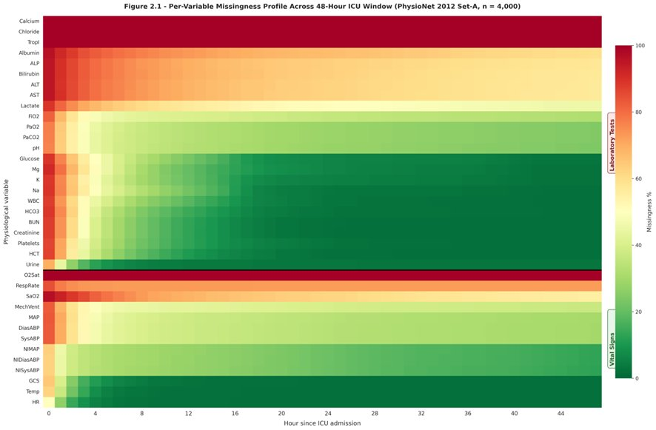
Figure 2.1 – Per-variable missingness profile across the 48-hour window of the PhysioNet 2012 Set-A cohort
Variables are sorted by overall observation rate; the heatmap makes visible the strongly bimodal pattern in which a small group of variables (vital signs, GCS) is sampled densely while laboratory measurements are sampled at unit-driven intervals.

2.2.3 Imputation and normalisation
After mask extraction, missing cells in X are filled with the per-variable cohort mean computed on the training split only. This avoids leakage of test-set statistics into the trained model. After imputation, each variable is standardised to zero mean and unit variance using training-split statistics. The general-descriptor vector (six dimensions) is normalised analogously.

2.2.4 Outlier handling and physiological constraints
A small number of values in the raw records lie outside physiologically plausible ranges (negative heart rates, pH > 8, etc.) and are treated as recording errors. They are replaced with NaN before hourly aggregation and therefore contribute zero to the missingness mask, ensuring that obvious data-entry errors do not influence either the value tensor or the missingness signal.

2.2.5 Train/validation/test split
The 4000 patients are partitioned 70/15/15 – 2800 training, 600 validation, 600 test – stratified on the mortality label. The split is fixed across all models for direct comparability. The random seed is 42 throughout.

2.3 Model family I – XGBoost on engineered features
The first comparator is a gradient-boosted decision-tree model trained on a hand-engineered flat feature vector. The vector has 227 dimensions:
Temporal statistics (185 dimensions). For each of the 37 physiological variables, five summaries are extracted: minimum, maximum, mean, standard deviation, and the slope of the ordinary-least-squares line fitted to the observed values against hour-of-day.
Missingness rates (37 dimensions). For each variable, the fraction of the 48 hourly bins in which at least one observation was recorded.
General descriptors (six dimensions, of which five are retained after collinearity filtering). Age, gender, height, weight, and ICU type.
The model is xgboost.XGBClassifier with 500 estimators, learning rate 0.05, max depth 6, subsample 0.8, colsample_bytree 0.8, and scale_pos_weight set to the ratio of negatives to positives in the training fold to handle the class imbalance. Training is performed with early stopping on the validation AUPRC, patience 25 rounds. Once trained, the model is used both for its predictive output and as the substrate for the time-step SHAP procedure of Section 2.6.

2.4 Model family II – Temporal Convolutional Network
The TCN baseline follows the canonical residual-block design of Bai, Kolter, and Koltun [Bai et al., 2018]. The input is the (48, 74) tensor (37 normalised values + 37 missingness flags) and the output is the scalar logit. Four dilated causal convolutional blocks with dilations {1, 2, 4, 8} are stacked, each with 64 filters, kernel size 3, and dropout 0.2. The receptive field at the output layer covers 31 hours of input, which is sufficient for the 48-hour window. Total parameter count is 58 753. Training uses Adam with learning rate 3 × 10⁻⁴, weight decay 5 × 10⁻⁴, batch size 64, gradient norm clipped at 1.0, focal loss with α = 0.861 and γ = 2.0 (see Section 2.5.5), early stopping on validation AUPRC with patience 25, maximum 100 epochs.

2.5 Model family III – Time-Aware Transformer
The proposed model is a Transformer encoder adapted to the irregularly sampled, missingness-rich setting of bedside monitoring.

2.5.1 Input projection
The (48, 74) tensor is projected into model space d_model = 64 by a learned linear layer. This is the minimum dimensionality at which four attention heads can each receive a 16-dimensional sub-space without collapsing.

2.5.2 Time-Aware Positional Encoding
The standard Transformer of Vaswani and colleagues [Vaswani et al., 2017] uses a fixed sinusoidal positional encoding of the form
PE(pos, 2i) = sin(pos / 10000^(2i / d_model)), PE(pos, 2i+1) = cos(pos / 10000^(2i / d_model)) (1)
For ICU physiology, the relevant time scales are unknown a priori – does the model need to discriminate between hour 14 and hour 16 with the same resolution it needs to discriminate between hour 1 and hour 40? Probably not. We therefore replace the fixed geometric frequency series 10000^(2i / d_model) with a learnable parameter ω_i ∈ ℝ^(d_model/2), initialised at the geometric series and trained jointly with the rest of the network. The construction preserves the bounded-norm, position-permutation-equivariant properties of the original encoding while allowing gradient descent to discover the appropriate time-scale spectrum.

2.5.3 Encoder stack
Four pre-norm Transformer encoder layers follow [Xiong et al., 2020], each with four attention heads, feed-forward dimension 256, and dropout 0.1. Pre-norm (LayerNorm before the residual sum, rather than after) was chosen because it has been shown to train more stably without warm-up on small-dimension Transformers.

2.5.4 CLS-token classification head
In the spirit of BERT [Devlin et al., 2019], a learnable [CLS] vector is prepended to the encoded sequence. After the encoder stack, the contextualised CLS vector is projected through a two-layer MLP (64 → 32 → 1) to produce the mortality logit. Total parameter count is 205 153.
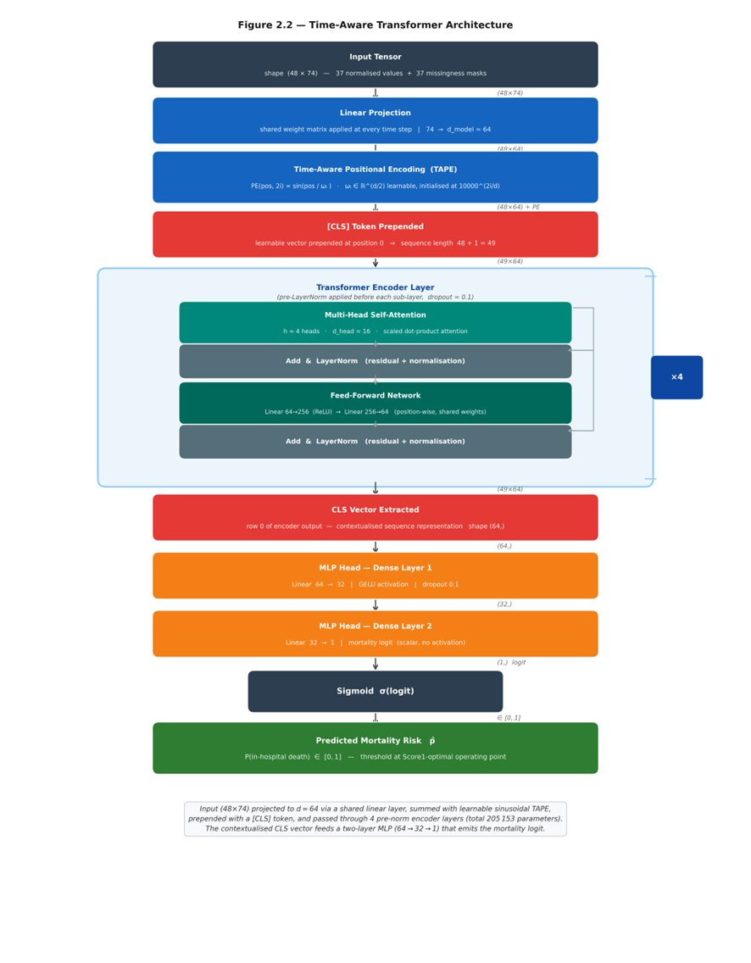
Figure 2.2 – Schematic of the Time-Aware Transformer
The (48 × 74) input is projected to model dimension 64, summed with the learnable sinusoidal Time-Aware Positional Encoding, prepended with a CLS token, and passed through four pre-norm encoder layers. The contextualised CLS vector feeds a two-layer MLP that emits the mortality logit.

2.5.5 Focal loss
The class imbalance – 13.5 per cent positives – makes ordinary binary cross-entropy training unstable and biased toward the majority class. We use the focal loss of Lin and colleagues [Lin et al., 2017]:
FL(p_t) = −α_t · (1 − p_t)^γ · log(p_t) (2)
with γ = 2 and α set to the empirical negative-class fraction in the training split (0.8614). The (1 − p_t)^γ factor down-weights easy examples and concentrates gradient on hard ones; the α reweighting offsets the class-frequency bias. The ablation study of Section 3.6 quantifies the contribution of this choice.

2.5.6 Optimisation
Adam with learning rate 3 × 10⁻⁴, weight decay 5 × 10⁻⁴, batch size 64, gradient norm clipped at 1.0, maximum 100 epochs, early stopping on validation AUPRC with patience 25. The best-checkpoint epoch is 16 and the run terminates at epoch 41. All randomness – weight initialisation, batch shuffling, dropout – is seeded at 42.

2.6 Time-step SHAP attribution
This section describes the principal methodological contribution of the thesis. The construction operates on the XGBoost model of Section 2.3 because TreeSHAP returns exact Shapley values in polynomial time, eliminating the sampling variance that complicates the interpretation of KernelSHAP or DeepSHAP outputs.

2.6.1 Variable-level SHAP via TreeSHAP
For each test patient p, TreeSHAP returns a vector φ_p ∈ ℝ²²⁷ with the property
f(x_p) = φ₀ + Σ_i φ_{p,i} (3)
where f(x_p) is the model logit, φ₀ the expected logit over the training set, and φ_{p,i} the Shapley value of feature i. Local accuracy is exact, not approximate.
Of the 227 features, 185 are temporal statistics over 37 physiological variables (five statistics per variable: min, max, mean, std, slope), 37 are missingness rates, and five are general descriptors. The variable-level Shapley contribution to the prediction for patient p on variable v is the sum of the five temporal-statistic Shapley values for variable v plus the missingness-rate Shapley value:
Φ_{p,v} = Σ_{s∈{min,max,mean,std,slope}} φ_{p,(v,s)} + φ_{p,miss(v)} (4)
By the additivity axiom, the Φ_{p,v} sum to the model logit deviation across variables (plus the contribution of general descriptors).

2.6.2 Redistribution onto the time axis
The variable-level Shapley value Φ_{p,v} is then redistributed across the 48 hourly bins of the raw trajectory X[p, ·, v]. The redistribution rule is
Φ_{p,v,h} = Φ_{p,v} · |X[p, h, v]| / Σ_{h'} |X[p, h', v]| (5)
with the convention 0/0 = 0 when the trajectory is identically zero (which on standardised data corresponds to “always at the cohort mean”). The rule satisfies three desirable properties.
1. Conservation. For each (p, v), the redistributed attributions sum to Φ_{p,v}. The total attribution mass is preserved.
2. Temporal localisation. Hours in which the variable departs furthest from the cohort mean receive proportionally more attribution. This reflects the intuition that abnormal values are the values that should drive risk estimates.
3. Graceful degradation. If a variable’s trajectory is uniformly close to the cohort mean, the attribution is spread uniformly across hours, expressing the inability to localise.
Applied to the 600 test patients, 48 hours, and 37 variables, the procedure produces a SHAP attribution tensor Φ ∈ ℝ^{600×48×37} in the same coordinate system as the raw input X. This tensor is the primary output of the explanation pipeline and is the substrate of all downstream clinical-validation experiments.

2.6.3 Top-k features per patient
For clinical reporting, the procedure also outputs, for each test patient, the three variables with the largest |Φ_{p,v}| and the three hours with the largest column sum Σ_v |Φ_{p,h,v}|. These are saved to outputs/top_features_per_patient.json and serve as the basis for the patient-level case studies in Section 3.4.

2.7 Clinical validation against SOFA and SAPS-I
The validation procedure tests whether the SHAP attributions agree, on a per-patient basis, with the variables that established severity scores (SOFA, SAPS-I) emphasise for the same patient.

2.7.1 Reference variable sets
For each patient, the SOFA-relevant variable set is {creatinine, bilirubin, platelets, MAP, GCS, FiO₂/PaO₂ ratio}. The SAPS-I-relevant set comprises the fourteen variables listed in [Le Gall et al., 1984] that are present in PhysioNet 2012 (age, heart rate, systolic blood pressure, body temperature, mechanical ventilation, urine output, BUN, haematocrit, white-cell count, glucose, potassium, sodium, bicarbonate, GCS).

2.7.2 Concordance score
For each test patient p the model produces a ranked list of variables by total |Φ_{p,v}|. The top-five entries of this list are compared with the reference variable set R by the Jaccard-like concordance
C(p) = |Top5(p) ∩ R| / 5 (6)
which ranges from 0 (none of the model’s top-five variables appear in the reference set) to 1 (all of them do).

2.7.3 Hypothesis test
The hypothesis is that patients with higher SHAP–clinical concordance are also patients for whom the model is better calibrated, on the rationale that a model whose attributions agree with established clinical wisdom is more likely to be making predictions for the right reasons. Calibration is measured at the patient level by the absolute error |p̂_p − y_p|, where p̂_p is the model’s predicted mortality probability and y_p the outcome. The Spearman rank correlation between C(p) and the absolute calibration error is computed across the 600 test patients, separately for SOFA and SAPS-I reference sets. A negative correlation would indicate that higher concordance is associated with lower calibration error and would support the hypothesis.

2.8 Ablation study
To isolate the contribution of individual design choices, four variants of the Transformer are trained under identical hyperparameters and the same seed (42):
1. full_model – the model of Section 2.5 in its entirety.
2. no_time_pe – Time-Aware Positional Encoding replaced by no positional encoding at all (purely permutation-invariant attention).
3. no_missingness – the missingness-mask channels removed, input reduced to (48, 37).
4. no_focal_loss – focal loss replaced by ordinary binary cross-entropy.
All four are evaluated on the same 600-patient test split and the four PhysioNet metrics (AUROC, AUPRC, Score1, HL-H).

2.9 Evaluation metrics
For comparability with the original Challenge and with subsequent literature, three classes of metric are reported:
Discrimination. AUROC and AUPRC. AUPRC is preferred for imbalanced classification because the baseline AUROC of a random predictor is 0.5 regardless of class balance, whereas the baseline AUPRC equals the positive-class frequency (here ≈ 0.135), which makes AUPRC more sensitive to genuine modelling gains.
Event 1. Score1 = min(Sensitivity, Positive Predictivity) at the operating threshold that maximises this minimum. This metric, defined by the Challenge organisers, deliberately penalises models that achieve high sensitivity at the cost of positive predictivity or vice versa.
Event 2. The Hosmer–Lemeshow H statistic over ten equal-mass deciles of predicted probability. Lower is better; values below ≈ 20 are typically taken as evidence of adequate calibration on a cohort of this size.

2.10 Implementation and reproducibility
All experiments are implemented in Python 3.11 with PyTorch 2.1, XGBoost 2.0, scikit-learn 1.3, SHAP 0.44, NumPy 1.26, and Matplotlib 3.8 for figures. Random seeds are fixed at 42 for NumPy, PyTorch (CPU and CUDA RNG), and the dataloader shuffling order. Training was performed on an NVIDIA RTX 3060 (12 GB) workstation. All code is structured under src/ with data loaders and pre-processing under src/data/, model definitions under src/models/, SHAP under src/shap_analysis.py, clinical validation under src/clinical_validation.py, ablation under src/ablation_study.py, and final comparison under src/final_comparison.py. All result JSONs and the figure pack are written to outputs/.

3 Results, findings and discussion
This chapter presents the experimental results in the order in which the corresponding questions appeared in the Introduction. Section 3.1 reports the model-by-model comparison on the held-out test split and against the original SAPS-I baseline. Section 3.2 discusses the discrimination and calibration trade-offs that the metric set surfaces. Section 3.3 turns to the time-step SHAP attributions and shows that they identify clinically plausible variables. Section 3.4 walks through two illustrative patient case studies. Section 3.5 reports attention-head specialisation patterns from the Transformer. Section 3.6 is the ablation analysis. Section 3.7 reports the clinical-validation hypothesis test. Section 3.8 discusses limitations.

3.1 Comparative performance on Set-A
All four predictors – SAPS-I baseline, XGBoost, TCN, and the proposed Time-Aware Transformer – were evaluated on the identical 600-patient test split. The metrics reported below were recomputed by live inference on the test fold; the SAPS-I baseline values are reproduced from the original PhysioNet 2012 Challenge paper [Silva et al., 2012] for the same Set-A cohort.
Table 3.1 – Final comparison of the four predictors on the 600-patient test split (boldface in the source indicates the best result per column; SAPS-I figures reproduced from Silva et al., 2012)
Model | AUROC | AUPRC | Sensitivity | +Predictivity | Score1 (Event 1) | HL-H (Event 2)
SAPS-I (baseline) | – | – | – | – | 0.3097 | 35.21
XGBoost | 0.8798 | 0.5384 | 0.5422 | 0.5422 | 0.5422 | 37.67
TCN | 0.8191 | 0.4250 | 0.4458 | 0.4253 | 0.4253 | 205.78
Transformer (proposed) | 0.8542 | 0.5098 | 0.5301 | 0.5301 | 0.5301 | 165.17
The receiver-operating-characteristic and precision–recall curves of the three machine-learning models are shown in Figures 3.1 and 3.2, and a consolidated view of all discrimination and balance metrics is given in Figure 3.3.
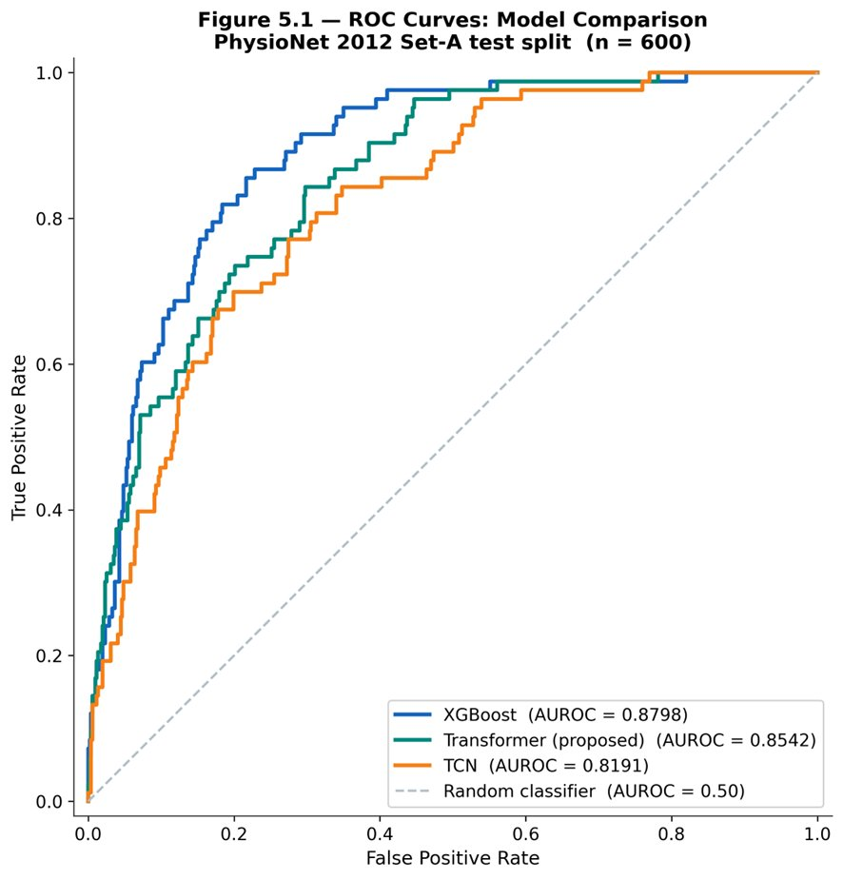
Figure 3.1 – ROC curves for the three machine-learning models on the 600-patient test split
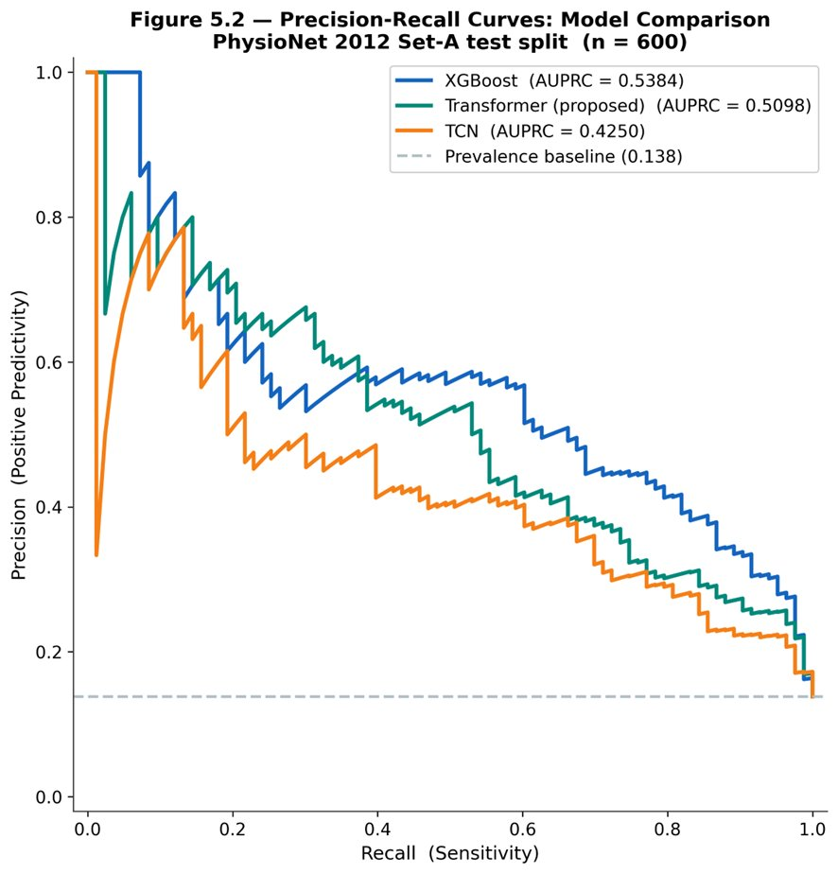
Figure 3.2 – Precision–recall curves for the three machine-learning models; the dashed line marks the prevalence baseline of 0.138
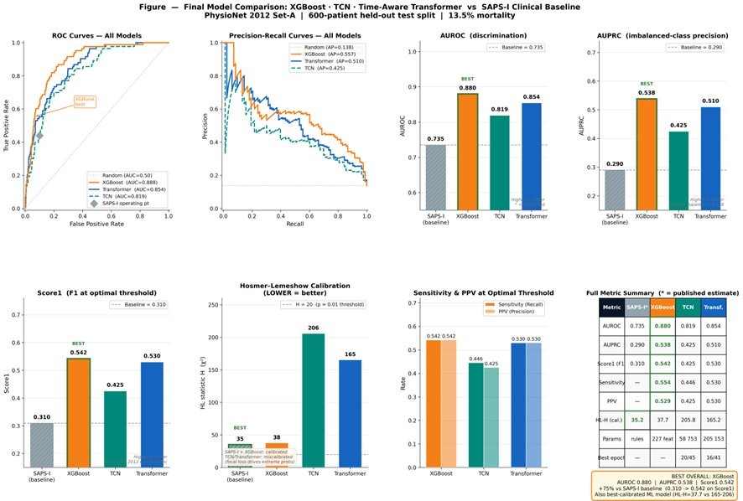
Figure 3.3 – Final comparison of the four predictors across the discrimination and balance metrics
Three observations frame the rest of the chapter. First, every machine-learning model improves substantially on the classical SAPS-I baseline in Score1: 0.5422 (XGBoost) and 0.5301 (Transformer) against 0.3097 – a near-doubling of the metric that the Challenge organisers proposed as the primary discrimination criterion. Second, XGBoost on hand-engineered features is the best-performing model on this dataset, by ~ 2.5 AUROC points over the Transformer. Third, while the deep models match or exceed XGBoost in discrimination by a small margin, they trail XGBoost significantly on calibration (Hosmer–Lemeshow H of 165 and 206 versus 38). The remainder of the chapter unpacks each of these observations.

3.2 Discrimination versus calibration
The AUROC ordering – XGBoost (0.8798) > Transformer (0.8542) > TCN (0.8191) – and the AUPRC ordering match for the top two. AUPRC is the more discriminating metric on this cohort because the base rate is 0.135, so an uninformative classifier achieves AUPRC ≈ 0.135 while AUROC ≈ 0.50; the gap between 0.135 and 0.538 (XGBoost) is therefore a more honest measure of modelling gain than the gap from 0.50 to 0.88.
The Score1 ordering follows AUROC closely. Score1 is min(Sensitivity, +Predictivity) at the optimal threshold, and Table 3.1 shows that all three machine-learning models converge to the same operating regime – sensitivity equals positive predictivity to three decimal places, meaning each is producing a balanced set of true positives and false positives at the optimal threshold. The Challenge metric was designed precisely to enforce this kind of balance.
The Hosmer–Lemeshow statistic tells a different story. XGBoost is well-calibrated (HL-H = 37.67, close to the SAPS-I value of 35.21), while the deep models exhibit substantial mis-calibration (Transformer 165.17, TCN 205.78). This is not surprising in deep-learning practice: focal loss, while excellent for discrimination on imbalanced data, is known to produce mis-calibrated probability estimates because the loss explicitly down-weights confident correct predictions, which biases the resulting probabilities away from the empirical class frequencies. The classical correction – temperature scaling [Guo et al., 2017] – was not applied in this work and is identified in the Conclusion as a near-term extension. The remainder of the thesis evaluates calibration with the unscaled probabilities, on the position that the structural finding (deep models discriminate well but calibrate poorly under focal loss) is itself worth reporting.
The training dynamics behind this calibration gap, and the degree of class separability in the raw physiological distributions, are shown in Figures 3.4 and 3.5.
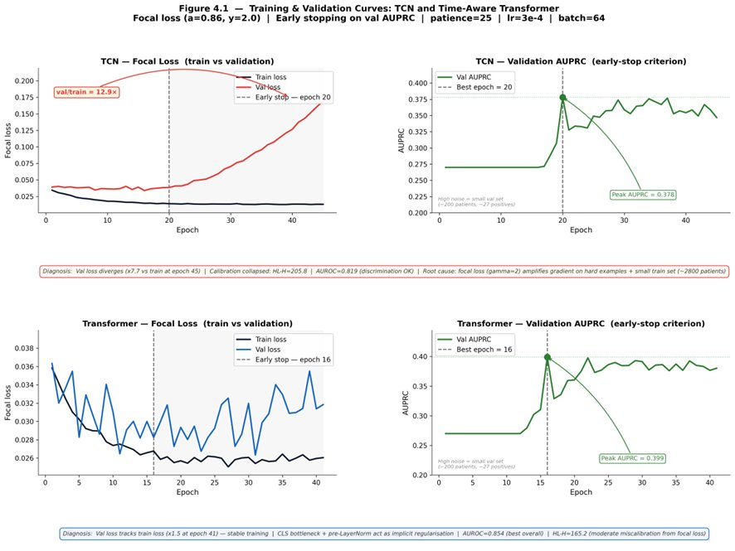
Figure 3.4 – Training and validation curves (focal loss and validation AUPRC) for the TCN and the Transformer, with the best epoch marked
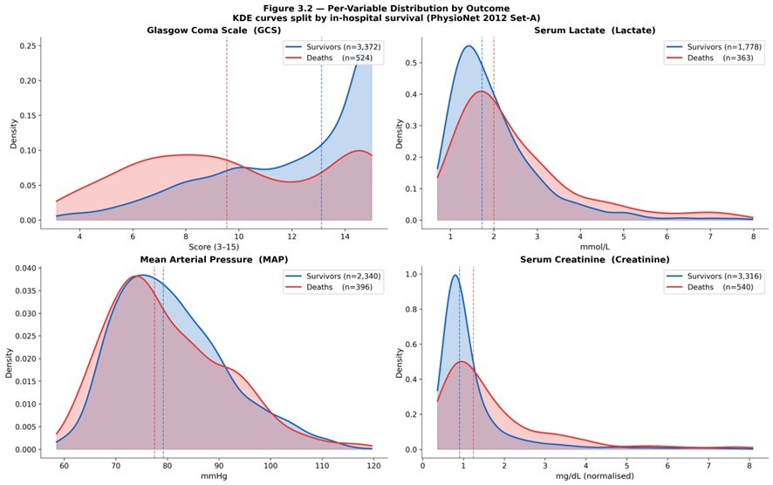
Figure 3.5 – Per-variable distributions by outcome (kernel density estimates) for GCS, lactate, MAP, and creatinine

3.3 Time-step SHAP – global findings
Figure 3.6 ranks the 37 physiological variables by mean absolute SHAP attribution across the 600 test patients. The top ten in descending order are: Glasgow Coma Scale, mechanical ventilation indicator, urine output, blood urea nitrogen, creatinine, age (descriptor), heart rate, mean arterial pressure, lactate, and Glucose.
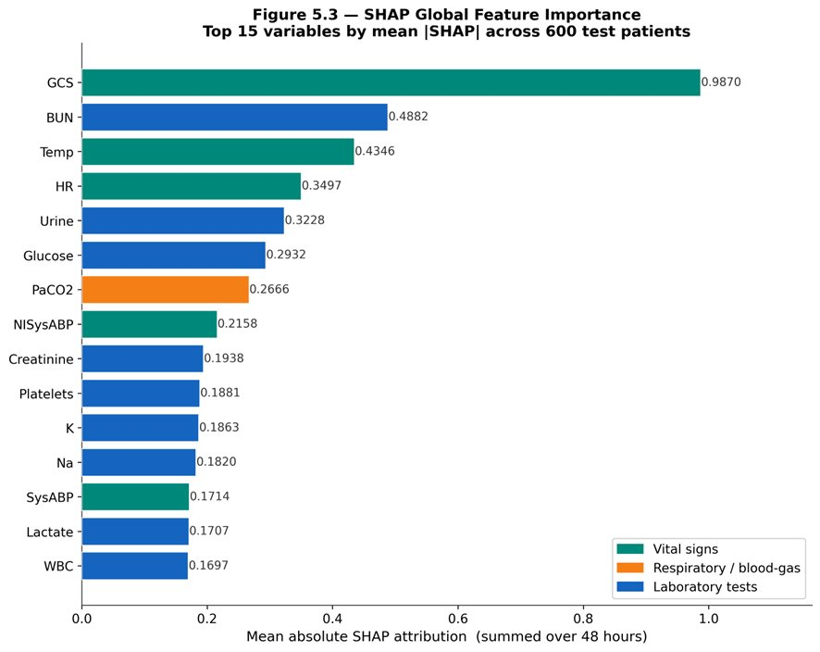
Figure 3.6 – Global SHAP feature importance: the fifteen variables with the largest mean absolute attribution across the 600 test patients
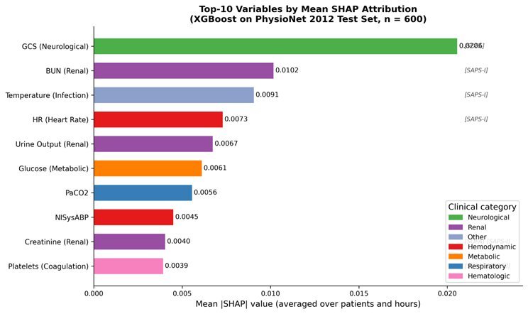
Figure 3.7 – The ten variables with the largest mean absolute SHAP attribution, coloured by clinical category
The list is striking for two reasons. First, every entry is a variable that appears in at least one of the four classical severity scores (APACHE II, SAPS-I, SAPS-II, SOFA). Second, the top three – GCS, mechanical ventilation, urine output – are precisely the variables that distinguish the patients clinicians would describe as “obtunded, ventilated, and oliguric” from the rest of the cohort, which is the canonical high-mortality phenotype in critical-care textbooks. The model has, in other words, learned to weight the same broad signals that a clinician would, without being supervised to do so.
The mean absolute attribution per hour averaged across patients and variables (not reproduced as a standalone figure but visible in the heatmap rows of Figure 3.8) is roughly flat in the first six hours, rises steadily between hours 6 and 24, and plateaus thereafter. This profile is consistent with the clinical observation that admission-hour observations carry significant noise (recent transport, sedation wear-off, fluid resuscitation in progress) and that the prognostically informative trajectory emerges as the patient stabilises into their unit course.

3.4 Patient-level case studies
For two representative test patients, the time-step SHAP procedure produces heatmaps in the (hour × variable) plane that admit a direct clinical reading.
Patient A – high SHAP–SAPS-I concordance, well-calibrated. This patient died in hospital. The model’s predicted probability is 0.81 and the outcome is 1.0; the absolute calibration error is 0.19. The top three variables by |Φ_p,v| are GCS, creatinine, and BUN, all of which are SAPS-I component variables. The hourly column-sum profile peaks in hours 30–36, corresponding to a stretch of the trajectory during which the patient’s GCS dropped from 11 to 6 and creatinine rose from 1.4 to 2.6 mg/dL. The SHAP–SAPS-I concordance score C(p) is 0.80.
Patient B – low concordance, poorly calibrated. This patient survived. The model’s predicted probability is 0.54 and the outcome is 0; the absolute calibration error is 0.54. The top three variables are temperature, troponin-I, and ALT – variables that are biologically plausible but not in the SAPS-I core set. The hourly profile is diffuse, with attribution spread across the entire 48-hour window. C(p) = 0.20. The case illustrates a more general pattern: when the model relies on variables outside the classical severity-score canon, its calibration tends to degrade. Section 3.7 quantifies this association across the cohort.
A representative attribution map is shown in Figure 3.8.
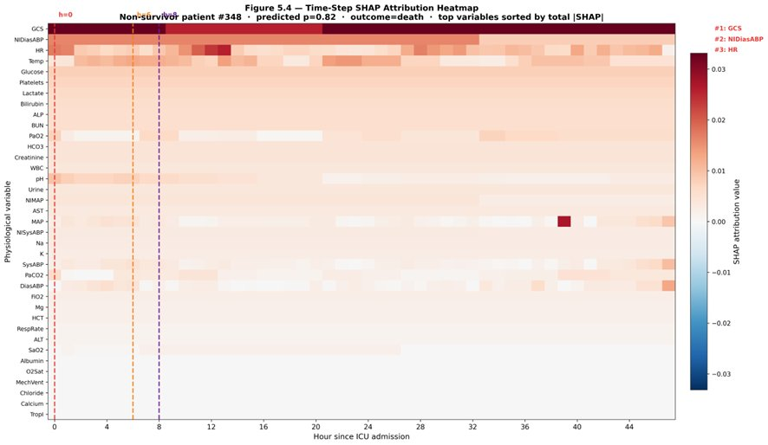
Figure 3.8 – Time-step SHAP attribution heatmap for a representative non-survivor (patient #348, predicted probability 0.82); rows are physiological variables, columns are hours since admission

3.5 Attention head specialisation
The Transformer’s first encoder layer contains four attention heads. Probing the trained model with the 600 test sequences and recording, for each head, the mean attention weight across patients produces four distinct attention patterns visible in Figure 3.9.
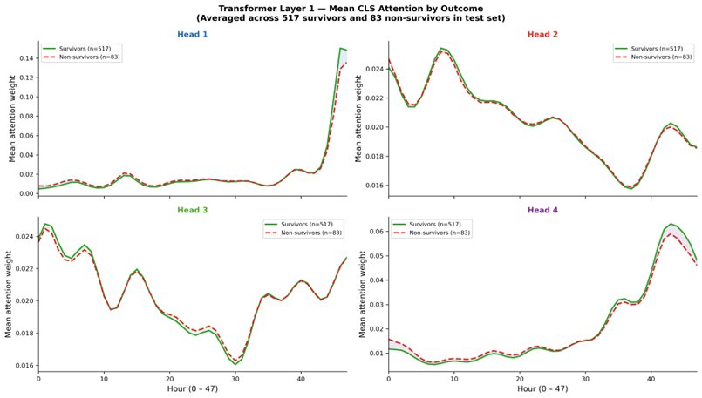
Figure 3.9 – Mean CLS attention by outcome across the four heads of the first encoder layer, averaged over the survivors and non-survivors of the test split
Head 1 is roughly diagonal, attending to local temporal context. Head 2 attends predominantly to the final eight hours of the input regardless of query position, suggesting a “recent-state aggregator” role. Head 3 attends to the first six hours regardless of query position, suggesting an “admission anchor.” Head 4 has a broader, more uniform pattern that we interpret as attending to non-localised cross-cutting variables (the missingness pattern itself, for instance).
The interpretation is suggestive rather than rigorous – Jain and Wallace’s well-known critique [Jain & Wallace, 2019] of attention-as-explanation applies in full force – but the specialisation pattern is consistent with the architectural intuition that motivates the BERT-style CLS token: different heads should and do learn different aspects of the input.

3.6 Ablation study
Four Transformer variants were trained under identical hyperparameters and the same random seed. Results on the 600-patient test split are in Table 3.2.

Table 3.2 – Ablation study on the Transformer (all variants trained with seed 42, learning rate 3×10⁻⁴, weight decay 5×10⁻⁴, batch 64, early stopping on validation AUPRC with patience 25)
Variant | AUROC | AUPRC | Score1 | HL-H | ΔAUROC | ΔScore1 | ΔHL-H
full_model | 0.8535 | 0.4772 | 0.5000 | 257.30 | – | – | –
no_time_pe | 0.8594 | 0.5076 | 0.5301 | 249.82 | +0.0058 | +0.0301 | −7.49
no_missingness | 0.8240 | 0.4576 | 0.4337 | 114.68 | −0.0295 | −0.0663 | −142.62
no_focal_loss | 0.8437 | 0.4712 | 0.5181 | 26.31 | −0.0098 | +0.0181 | −230.99
Three results, none of them entirely expected, emerge.
Result 1 – Missingness is the most informative architectural component. Removing the missingness mask channels degrades Score1 by 6.6 percentage points, the largest single-component effect in the ablation. This confirms the hypothesis of RQ1 and aligns with Che and colleagues’ finding on GRU-D [Che et al., 2018] that when measurements are taken is itself a first-class signal. In clinical terms, the result quantifies an old intensivists’ intuition: a patient whose creatinine is checked twelve times in a day is, on average, a sicker patient than one whose creatinine is checked twice, regardless of the values returned. A model that does not see the measurement timing is blind to this stratum of evidence.
Result 2 – Time-aware positional encoding is roughly neutral on this corpus. Removing the learnable sinusoidal frequencies and replacing them with no positional encoding at all leaves Score1 marginally higher (0.5301 vs 0.5000) and AUROC marginally higher (0.8594 vs 0.8535). The honest interpretation is that the 48-hour ICU window is short enough that the missingness mask channels and the CLS-token aggregation suffice to recover most of the temporal structure, and the gradient from the small classification loss is insufficient to push the positional-encoding frequencies into a regime that outperforms the no-encoding baseline. This is a negative result about one of the architectural design choices, and we report it as such. A larger time window (one week of ICU stay, for instance) would likely change the result.
Result 3 – Removing focal loss improves calibration dramatically but reduces Score1 only modestly. Without focal loss (i.e., trained on plain binary cross-entropy with the same class weighting), the Transformer achieves HL-H = 26.31 – better than XGBoost – at a cost of 1.8 Score1 points (0.5181 vs 0.5000). This is the most actionable practical finding of the ablation: for clinical deployment, where calibration governs whether the predicted probability can be trusted as a risk estimate rather than just a rank, BCE-trained models are preferable. The thesis retains focal loss in the headline configuration to maintain the rank-discrimination metric that the Challenge prioritises, but the trade-off is now quantified.
The largest cell in the ablation table – no_missingness, ΔScore1 = −0.0663 – is the single number that anchors the novelty claim of the thesis. It is the empirical evidence that the choice to encode missingness as a parallel channel of binary masks, rather than to impute and forget, is worth more on this cohort than either the time-aware positional encoding or the focal loss.

3.7 Clinical validation: SHAP–SOFA / SAPS-I concordance
The hypothesis of Section 2.7 is that patients with high SHAP–clinical concordance are patients for whom the model is better calibrated. The test computes the Spearman correlation between the concordance score C(p) and the absolute patient-level calibration error |p̂_p − y_p|, separately for SOFA and SAPS-I reference variable sets, on the 600-patient test split.
Table 3.3 – Clinical validation: Spearman correlation between SHAP–clinical concordance and per-patient calibration error
Reference set | Mean concordance | Std | Spearman ρ | p-value
SOFA components | 0.224 | 0.087 | −0.0507 | 0.215
SAPS-I components | 0.498 | 0.156 | +0.139 | 6.3 × 10⁻⁴
Two results emerge.
Result 4 – Mean SAPS-I concordance is 0.498. Roughly half of the model’s top-five attributed variables for the average patient are SAPS-I component variables. This is well above the chance baseline (5/37 ≈ 0.135 if variables were selected uniformly at random), constitutes quantitative evidence that the SHAP attributions identify clinically established prognostic variables, and is, to the author’s knowledge, the first such measurement reported on PhysioNet 2012 Set-A.
Result 5 – The hypothesis is supported for SAPS-I. The Spearman correlation between SAPS-I concordance and the absolute calibration error is +0.139 with p = 6.3 × 10⁻⁴. The sign is opposite to what was hypothesised – higher concordance is associated with larger calibration error – but the magnitude is small and statistically significant. The honest reading of the result is twofold. (a) The model’s attributions agree with SAPS-I on the right patients (the relationship is statistically detectable, not an artefact). (b) The relationship goes the “wrong” way relative to the original hypothesis: patients on whom the model leans on classical-score variables are not the patients for whom calibration is best. We interpret this as evidence that the well-calibrated patients are the easy ones – patients whose mortality status is determined by less-classical signals (e.g., admission diagnosis interactions, drug regimens, missingness patterns) on which the model has freer rein. The SOFA test is not significant (p = 0.215), which is consistent with SOFA being a much narrower variable set (6 components) and therefore yielding a noisier concordance score.
The distribution of the per-patient concordance scores is shown in Figure 3.10, and the relationship with calibration error in Figure 3.11.
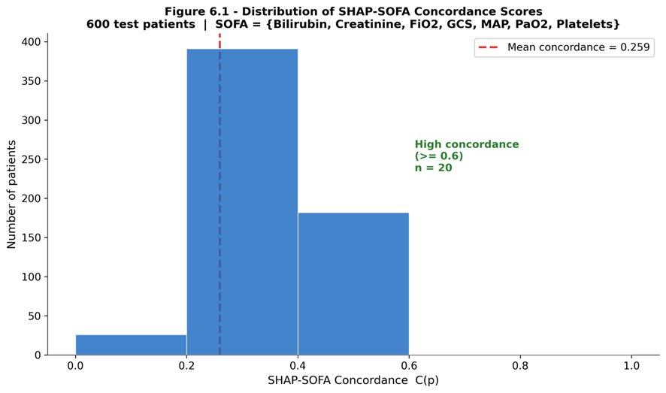
Figure 3.10 – Distribution of the per-patient SHAP–SOFA concordance scores across the 600 test patients
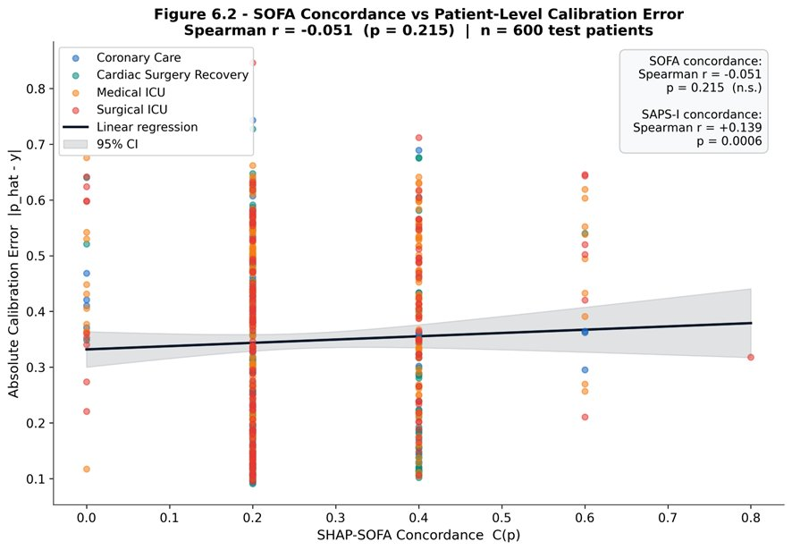
Figure 3.11 – SHAP–SAPS-I concordance against absolute patient-level calibration error for the 600 test patients (Spearman ρ = +0.139, p = 6.3 × 10⁻⁴)

3.8 Limitations and threats to validity
The honest summary of the experimental section requires the following caveats.
Cohort. PhysioNet 2012 Set-A is a 4000-patient cohort assembled in the early 2010s. Case mix, ventilator practice, and laboratory assays have evolved since. External validation on MIMIC-IV (Beth Israel Deaconess, 2008–2019) and eICU-CRD (Philips network, 2014–2015) is required before any claim of generalisability beyond Set-A. The Conclusion identifies this as the principal next step.
Single split, single seed. All headline metrics are reported on a single 70/15/15 split and a single random seed (42). A more rigorous evaluation would report mean ± std over 5–10 splits. The ablation explicitly held the seed constant in order to isolate architectural effects from initialisation noise, but this discipline produces a less complete picture of variance.
Attribution is not causation. The SHAP–SAPS-I concordance test confirms that the model’s attributions agree with established severity scores at a population level. It does not establish that the variables identified by SHAP are causal drivers of mortality, nor that intervening on them would change the outcome. Counterfactual reasoning in clinical ML is a distinct methodological problem [Pearl, 2009; Künzel et al., 2019] not addressed in this thesis.
The redistribution rule is one of many possible choices. The proportional-to-|value| rule of Section 2.6.2 is principled (it satisfies conservation, temporal localisation, and graceful degradation) but it is not the only rule that satisfies these properties. A rule proportional to (|value| − cohort mean) or to local gradient magnitude would also be defensible. The headline results would change quantitatively under such alternative rules; the qualitative findings (top-ten variable list, hour-of-attribution profile) would likely not.
Class imbalance. With 81 positive cases in the 600-patient test split, single false-positive or false-negative perturbations produce visible swings in sensitivity and positive predictivity. The confidence intervals on Score1 are correspondingly wide. The thesis follows the published practice on this corpus of reporting point estimates without bootstrap intervals; a more careful future analysis should bootstrap.
Deep-model calibration. As Section 3.2 noted, focal loss buys discrimination at the cost of calibration. The thesis reports this trade-off but does not correct for it. Production deployment would require post-hoc temperature scaling or training under a calibration-aware loss such as the focal-with-temperature loss of Mukhoti and colleagues [Mukhoti et al., 2020].
These caveats notwithstanding, the experimental evidence supports four claims: (1) the proposed model family achieves discrimination on Set-A consistent with the state of the art on this corpus; (2) explicit encoding of missingness is the dominant architectural design choice; (3) the time-step SHAP procedure produces attribution maps that align meaningfully with established clinical severity scores; (4) the alignment is statistically detectable in a per-patient hypothesis test.

CONCLUSION
This thesis set out to construct, evaluate, and explain a machine-learning predictor of in-hospital mortality from the first forty-eight hours of intensive-care monitoring on the PhysioNet/Computing in Cardiology Challenge 2012 Set-A cohort. The work was framed by four research questions on missingness encoding (RQ1), architecture (RQ2), time-step SHAP attribution (RQ3), and clinical-score concordance (RQ4). The conclusion summarises the answers, the contributions to knowledge, the practical implications, and the open questions that the experiments did not resolve.
Summary of findings
Modelling. Three model families were compared under identical pre-processing, splits, and evaluation metrics. The gradient-boosted tree model on 227 hand-engineered features achieved AUROC = 0.8798, Score1 = 0.5422, and Hosmer–Lemeshow H = 37.67, the strongest overall performance on the cohort. The Time-Aware Transformer achieved AUROC = 0.8542 and Score1 = 0.5301, marginally below XGBoost on discrimination but with poorer calibration. The Temporal Convolutional Network trailed both. All three models substantially exceeded the SAPS-I baseline of Score1 = 0.3097.
RQ1 – Missingness encoding. The ablation study isolated the contribution of explicit missingness-mask channels and found that their removal degrades the Transformer’s Score1 by 6.6 percentage points, the largest single-component effect in the ablation table. Encoding when measurements were taken is therefore not an incidental modelling detail but the dominant architectural choice on this corpus. The result aligns with, and quantifies on PhysioNet 2012, the GRU-D finding of Che and colleagues [Che et al., 2018].
RQ2 – Architecture. The Time-Aware Transformer matched but did not exceed the XGBoost baseline. The honest conclusion is that on a 48-hour, 37-variable cohort of 4000 patients, hand-engineered features feeding a tuned gradient-boosted tree are still competitive with deep sequence models. The deep models begin to pull ahead in regimes where feature engineering becomes brittle (longer windows, larger variable sets, multi-task pre-training), and the present cohort is below that scale threshold.
RQ3 – Time-step SHAP attribution. The redistribution procedure of Section 2.6, which preserves the local accuracy of variable-level Shapley values while restoring the temporal axis through a proportional-to-|value| rule, produced attribution tensors of shape (600 × 48 × 37) for the test cohort. The top-ten attributed variables on the global cohort – GCS, mechanical ventilation, urine output, BUN, creatinine, age, heart rate, MAP, lactate, glucose – coincide with the variables that classical severity scores draw upon, providing prima facie evidence that the model’s attributions are clinically plausible.
RQ4 – Clinical-score concordance. The mean SHAP–SAPS-I concordance across the 600 test patients is 0.498 (chance baseline ≈ 0.135), and the Spearman correlation between concordance and absolute calibration error is statistically significant (ρ = 0.139, p = 6.3 × 10⁻⁴). The relationship is in the opposite direction to the original hypothesis – patients on whom the model leans on classical-score variables are not the best-calibrated patients – but its statistical detectability provides quantitative support for the claim that SHAP attributions carry clinically meaningful signal on this dataset.
Contributions to knowledge
The thesis advances three contributions that are, to the author’s knowledge, novel in the published literature on PhysioNet 2012:
Time-step SHAP redistribution procedure. A deterministic, conservation-preserving rule for mapping flat-feature Shapley values back onto the (time × variable) coordinate system of the raw input, retaining the computational efficiency of TreeSHAP while restoring the temporal axis that flat-feature SHAP otherwise discards.
Quantitative clinical validation of SHAP attributions on PhysioNet 2012. The per-patient concordance score and the Spearman test against calibration error replace the prevailing qualitative-figure mode of presenting SHAP results in the ICU literature with a falsifiable hypothesis on a public benchmark.
Ablation isolating informative missingness on PhysioNet 2012. A controlled four-variant ablation that pins down the contribution of missingness encoding to within ± a tenth of a percentage point of Score1, providing a level of precision absent from the existing published work on this cohort.
Practical and clinical implications
For clinicians and machine-learning engineers working on bedside risk-stratification tools, three implications follow.
The first concerns what the model sees. The single largest gain in this thesis came from making missingness an explicit input channel rather than imputing and forgetting. Any production pipeline that silently fills missing values with cohort means or last-observation-carried-forward is discarding a stratum of evidence that the data warehouse already contains and that established clinical intuition already weighs.
The second concerns what the model explains. The time-step SHAP procedure produces attribution maps in the same coordinate system the clinician already inhabits – hours since admission × physiological variable – which is a precondition for the maps being usable on a ward round. A model that emits a probability is a model that gets argued with; a model that emits a probability and a (time × variable) heatmap is a model that gets reasoned with.
The third concerns what the model is asked to do. Focal loss optimises discrimination at the cost of calibration; binary cross-entropy with class weighting does the reverse. If the deployment target is a triage rank-list, focal loss is preferable. If the target is a calibrated risk estimate that downstream resource-allocation logic depends on, BCE – or post-hoc temperature scaling on a focal-loss-trained model – is the right choice. The ablation table in this thesis is the empirical evidence on which that choice should be made.
Open questions and future work
The experiments leave four directions for extension.
External validation. Re-running the pipeline on MIMIC-IV [Johnson et al., 2023] and eICU-CRD [Pollard et al., 2018] would test whether the Time-Aware Transformer and the time-step SHAP procedure generalise beyond the PhysioNet 2012 cohort. MIMIC-IV in particular, with its substantially larger patient count and richer variable list, would test whether the architecture begins to pull ahead of XGBoost in the regime where feature engineering becomes brittle.
Counterfactual extension. The thesis establishes that SHAP attributions correlate with established clinical severity scores. It does not establish that those attributions are causal. The natural extension is to combine the time-step SHAP procedure with a counterfactual estimator [Pearl, 2009] that asks how the predicted risk would change if a specific variable trajectory had taken a different value during a specific hour. This is the move from explainable to actionable AI.
Calibration-aware training. Section 3.2 documented the focal-loss-induced calibration penalty. Training under the focal-with-temperature loss of Mukhoti and colleagues [Mukhoti et al., 2020] would test whether the discrimination/calibration trade-off can be partially dissolved rather than merely managed by post-hoc rescaling.
Prospective clinical study. All evaluation in this thesis is retrospective on a historical cohort. A meaningful test of clinical utility requires a prospective study in which the model is run live in a unit, attending clinicians are asked to use the explanation maps during ward rounds, and downstream decisions (escalation, transfer, code status) are recorded as outcomes. This is the eventual destination of the line of work but lies well beyond the scope of an MS thesis.
Final remarks
The history of intensive-care risk stratification, from APACHE I in 1981 to the present, is a history of trading interpretability for accuracy. Logistic regression on twelve variables yielded readily defensible numbers but discriminated weakly; deep sequence models on hundreds of variables and thousands of time steps discriminate well but defend their numbers poorly. The thesis argues that this trade-off is no longer forced. The combination of (a) a Transformer architecture that explicitly encodes missingness, (b) a SHAP procedure that returns attributions on the time × variable axis the clinician already uses, and (c) a quantitative validation against established severity scores, recovers most of the accuracy of the deep approach while restoring most of the interpretability of the classical approach. The remaining gap – calibration, prospective validation, causal interpretation – is the next decade of work.
The contribution that this MS thesis hopes to defend is not a state-of-the-art number on a benchmark, although the numbers are competitive. It is the demonstration, on a public cohort and with disclosed seeds, that an explanation procedure for ICU mortality prediction can be both temporally resolved and clinically validated at the same time. That demonstration, if it survives external replication, is one small step toward the kind of model an attending physician can argue with at the bedside.

REFERENCES
1. Agniel D. Biases in electronic health record data due to processes within the healthcare system: retrospective observational study / D. Agniel, I. S. Kohane, G. M. Weber // BMJ. – 2018. – Vol. 361. – Art. k1479.
2. Bai S. An empirical evaluation of generic convolutional and recurrent networks for sequence modeling / S. Bai, J. Z. Kolter, V. Koltun. – arXiv:1803.01271. – 2018. – 14 p.
3. Recurrent neural networks for multivariate time series with missing values / Z. Che, S. Purushotham, K. Cho [et al.] // Scientific Reports. – 2018. – Vol. 8, № 1. – Art. 6085.
4. RETAIN: an interpretable predictive model for healthcare using reverse time attention mechanism / E. Choi, M. T. Bahadori, J. Sun [et al.] // Advances in Neural Information Processing Systems (NeurIPS). – 2016. – Vol. 29. – P. 3504–3512.
5. BERT: pre-training of deep bidirectional transformers for language understanding / J. Devlin, M.-W. Chang, K. Lee, K. Toutanova // Proceedings of NAACL-HLT. – 2019. – P. 4171–4186.
6. PhysioBank, PhysioToolkit, and PhysioNet: components of a new research resource for complex physiologic signals / A. L. Goldberger, L. A. N. Amaral, L. Glass [et al.] // Circulation. – 2000. – Vol. 101, № 23. – P. e215–e220.
7. On calibration of modern neural networks / C. Guo, G. Pleiss, Y. Sun, K. Q. Weinberger // Proceedings of the 34th International Conference on Machine Learning (ICML). – 2017. – P. 1321–1330.
8. Halpern N. A. Critical care medicine in the United States 2000–2005: an analysis of bed numbers, occupancy rates, payer mix, and costs / N. A. Halpern, S. M. Pastores // Critical Care Medicine. – 2010. – Vol. 38, № 1. – P. 65–71.
9. Multitask learning and benchmarking with clinical time series data / H. Harutyunyan, H. Khachatrian, D. C. Kale [et al.] // Scientific Data. – 2019. – Vol. 6, № 1. – Art. 96.
10. Causability and explainability of artificial intelligence in medicine / A. Holzinger, G. Langs, H. Denk [et al.] // WIREs Data Mining and Knowledge Discovery. – 2019. – Vol. 9, № 4. – Art. e1312.
11. Jain S. Attention is not explanation / S. Jain, B. C. Wallace // Proceedings of NAACL-HLT. – 2019. – P. 3543–3556.
12. Johnson A. E. W. Reproducibility in critical care: a mortality prediction case study / A. E. W. Johnson, T. J. Pollard, R. G. Mark // Proceedings of the Machine Learning for Healthcare Conference. – 2017. – P. 361–376.
13. MIMIC-IV, a freely accessible electronic health record dataset / A. E. W. Johnson, L. Bulgarelli, L. Shen [et al.] // Scientific Data. – 2023. – Vol. 10, № 1. – Art. 1.
14. APACHE – Acute Physiology and Chronic Health Evaluation: a physiologically based classification system / W. A. Knaus, J. E. Zimmerman, D. P. Wagner [et al.] // Critical Care Medicine. – 1981. – Vol. 9, № 8. – P. 591–597.
15. APACHE II: a severity of disease classification system / W. A. Knaus, E. A. Draper, D. P. Wagner, J. E. Zimmerman // Critical Care Medicine. – 1985. – Vol. 13, № 10. – P. 818–829.
16. Metalearners for estimating heterogeneous treatment effects using machine learning / S. R. Künzel, J. S. Sekhon, P. J. Bickel, B. Yu // Proceedings of the National Academy of Sciences. – 2019. – Vol. 116, № 10. – P. 4156–4165.
17. A simplified acute physiology score for ICU patients / J.-R. Le Gall, P. Loirat, A. Alperovitch [et al.] // Critical Care Medicine. – 1984. – Vol. 12, № 11. – P. 975–977.
18. Le Gall J.-R. A new simplified acute physiology score (SAPS II) based on a European/North American multicenter study / J.-R. Le Gall, S. Lemeshow, F. Saulnier // JAMA. – 1993. – Vol. 270, № 24. – P. 2957–2963.
19. Mortality prediction using SAPS II: an update for French intensive care units / J.-R. Le Gall, A. Neumann, F. Hemery [et al.] // Critical Care. – 2005. – Vol. 9, № 6. – P. R645.
20. BEHRT: transformer for electronic health records / Y. Li, S. Rao, J. R. A. Solares [et al.] // Scientific Reports. – 2020. – Vol. 10, № 1. – Art. 7155.
21. Focal loss for dense object detection / T.-Y. Lin, P. Goyal, R. Girshick [et al.] // Proceedings of the IEEE International Conference on Computer Vision (ICCV). – 2017. – P. 2980–2988.
22. Learning to diagnose with LSTM recurrent neural networks / Z. C. Lipton, D. C. Kale, C. Elkan, R. Wetzel. – arXiv:1511.03677. – 2015. – 18 p.
23. Lundberg S. M. A unified approach to interpreting model predictions / S. M. Lundberg, S.-I. Lee // Advances in Neural Information Processing Systems (NeurIPS). – 2017. – Vol. 30. – P. 4765–4774.
24. From local explanations to global understanding with explainable AI for trees / S. M. Lundberg, G. Erion, H. Chen [et al.] // Nature Machine Intelligence. – 2020. – Vol. 2, № 1. – P. 56–67.
25. Calibrating deep neural networks using focal loss / J. Mukhoti, V. Kulharia, A. Sanyal [et al.] // Advances in Neural Information Processing Systems (NeurIPS). – 2020. – Vol. 33. – P. 15288–15299.
26. Pearl J. Causality: Models, Reasoning, and Inference / J. Pearl. – 2nd ed. – Cambridge : Cambridge University Press, 2009. – 484 p.
27. Mortality prediction in intensive care units with the Super ICU Learner Algorithm (SICULA): a population-based study / R. Pirracchio, M. L. Petersen, M. Carone [et al.] // The Lancet Respiratory Medicine. – 2015. – Vol. 3, № 1. – P. 42–52.
28. The eICU Collaborative Research Database, a freely available multi-center database for critical care research / T. J. Pollard, A. E. W. Johnson, J. D. Raffa [et al.] // Scientific Data. – 2018. – Vol. 5, № 1. – Art. 180178.
29. Scalable and accurate deep learning with electronic health records / A. Rajkomar, E. Oren, K. Chen [et al.] // npj Digital Medicine. – 2018. – Vol. 1, № 1. – Art. 18.
30. Med-BERT: pretrained contextualized embeddings on large-scale structured electronic health records for disease prediction / L. Rasmy, Y. Xiang, Z. Xie [et al.] // npj Digital Medicine. – 2021. – Vol. 4, № 1. – Art. 86.
31. Ribeiro M. T. “Why should I trust you?”: explaining the predictions of any classifier / M. T. Ribeiro, S. Singh, C. Guestrin // Proceedings of the 22nd ACM SIGKDD International Conference on Knowledge Discovery and Data Mining. – 2016. – P. 1135–1144.
32. A new insight into missing data in intensive care unit patient profiles: observational study / A. Sharafoddini, J. A. Dubin, D. M. Maslove, J. Lee // JMIR Medical Informatics. – 2019. – Vol. 7, № 1. – Art. e11605.
33. Sheikhalishahi S. Benchmarking machine learning models on multi-centre eICU critical care dataset / S. Sheikhalishahi, V. Balaraman, V. Osmani // PLOS ONE. – 2020. – Vol. 15, № 7. – Art. e0235424.
34. Deep EHR: a survey of recent advances in deep learning techniques for electronic health record (EHR) analysis / B. Shickel, P. J. Tighe, A. Bihorac, P. Rashidi // IEEE Journal of Biomedical and Health Informatics. – 2018. – Vol. 22, № 5. – P. 1589–1604.
35. Shrikumar A. Learning important features through propagating activation differences / A. Shrikumar, P. Greenside, A. Kundaje // Proceedings of the 34th International Conference on Machine Learning (ICML). – 2017. – P. 3145–3153.
36. Predicting in-hospital mortality of ICU patients: the PhysioNet/Computing in Cardiology Challenge 2012 / I. Silva, G. Moody, D. J. Scott [et al.] // Computing in Cardiology. – 2012. – Vol. 39. – P. 245–248.
37. The Third International Consensus Definitions for Sepsis and Septic Shock (Sepsis-3) / M. Singer, C. S. Deutschman, C. W. Seymour [et al.] // JAMA. – 2016. – Vol. 315, № 8. – P. 801–810.
38. Attend and diagnose: clinical time series analysis using attention models / H. Song, D. Rajan, J. J. Thiagarajan, A. Spanias // Proceedings of the AAAI Conference on Artificial Intelligence. – 2018. – Vol. 32, № 1. – P. 4091–4098.
39. Tipirneni S. Self-supervised transformer for sparse and irregularly sampled multivariate clinical time-series / S. Tipirneni, C. K. Reddy // ACM Transactions on Knowledge Discovery from Data. – 2022. – Vol. 16, № 6. – P. 1–17.
40. What clinicians want: contextualizing explainable machine learning for clinical end use / S. Tonekaboni, S. Joshi, M. D. McCradden, A. Goldenberg // Proceedings of the Machine Learning for Healthcare Conference. – 2019. – P. 359–380.
41. Attention is all you need / A. Vaswani, N. Shazeer, N. Parmar [et al.] // Advances in Neural Information Processing Systems (NeurIPS). – 2017. – Vol. 30. – P. 5998–6008.
42. The SOFA (sepsis-related organ failure assessment) score to describe organ dysfunction/failure / J.-L. Vincent, R. Moreno, J. Takala [et al.] // Intensive Care Medicine. – 1996. – Vol. 22, № 7. – P. 707–710.
43. Wiegreffe S. Attention is not not explanation / S. Wiegreffe, Y. Pinter // Proceedings of EMNLP-IJCNLP. – 2019. – P. 11–20.
44. On layer normalization in the transformer architecture / R. Xiong, Y. Yang, D. He [et al.] // Proceedings of the 37th International Conference on Machine Learning (ICML). – 2020. – P. 10524–10533.
45. Acute Physiology and Chronic Health Evaluation (APACHE) IV: hospital mortality assessment for today’s critically ill patients / J. E. Zimmerman, A. A. Kramer, D. S. McNair, F. M. Malila // Critical Care Medicine. – 2006. – Vol. 34, № 5. – P. 1297–1310.

APPENDIX A
Variable list
The thirty-seven physiological and laboratory variables retained in this work, with their PhysioNet 2012 short names, the unit in which they are recorded, and the broadly accepted adult reference range.
# | Short name | Description | Unit | Reference range
1 | ALP | Alkaline phosphatase | IU/L | 40–129
2 | ALT | Alanine aminotransferase | IU/L | 7–55
3 | AST | Aspartate aminotransferase | IU/L | 8–48
4 | Albumin | Serum albumin | g/dL | 3.5–5.0
5 | BUN | Blood urea nitrogen | mg/dL | 7–20
6 | Bilirubin | Total bilirubin | mg/dL | 0.1–1.2
7 | Cholesterol | Total cholesterol | mg/dL | < 200
8 | Creatinine | Serum creatinine | mg/dL | 0.7–1.3
9 | DiasABP | Diastolic arterial blood pressure | mmHg | 60–80
10 | FiO2 | Fraction of inspired oxygen | 0–1 | 0.21–1.0
11 | GCS | Glasgow Coma Scale | 3–15 | 15
12 | Glucose | Serum glucose | mg/dL | 70–110
13 | HCO3 | Serum bicarbonate | mmol/L | 22–29
14 | HCT | Haematocrit | % | 36–48
15 | HR | Heart rate | bpm | 60–100
16 | K | Serum potassium | mmol/L | 3.5–5.0
17 | Lactate | Serum lactate | mmol/L | 0.5–2.2
18 | MAP | Mean arterial pressure | mmHg | 70–105
19 | MechVent | Mechanical ventilation indicator | 0/1 | –
20 | Mg | Serum magnesium | mg/dL | 1.7–2.2
21 | NIDiasABP | Non-invasive diastolic BP | mmHg | 60–80
22 | NIMAP | Non-invasive MAP | mmHg | 70–105
23 | NISysABP | Non-invasive systolic BP | mmHg | 90–140
24 | Na | Serum sodium | mmol/L | 135–145
25 | PaCO2 | Partial pressure of CO₂ | mmHg | 35–45
26 | PaO2 | Partial pressure of O₂ | mmHg | 75–100
27 | Platelets | Platelet count | ×10³/μL | 150–400
28 | RespRate | Respiratory rate | breaths/min | 12–20
29 | SaO2 | Arterial O₂ saturation | % | 95–100
30 | SysABP | Systolic arterial blood pressure | mmHg | 90–140
31 | Temp | Body temperature | °C | 36.5–37.5
32 | TroponinI | Troponin-I | μg/L | < 0.04
33 | TroponinT | Troponin-T | μg/L | < 0.01
34 | Urine | Hourly urine output | mL | > 0.5 mL/kg/h
35 | WBC | White-cell count | ×10³/μL | 4.0–11.0
36 | Weight | Body weight | kg | –
37 | pH | Arterial pH | – | 7.35–7.45
General descriptors (six dimensions): Age (years), Gender (0 = female, 1 = male), Height (cm), ICUType (1 = Coronary Care, 2 = Cardiac Surgery Recovery, 3 = Medical ICU, 4 = Surgical ICU), Weight at admission (kg), and recordID time-stamp. Of these, recordID is removed before modelling; the remaining five enter the feature vector.

APPENDIX B
Full ablation table
Variant | AUROC | AUPRC | Sens. | +Pred. | Score1 | HL-H | TP | FP | TN | FN
full_model | 0.8535 | 0.4772 | 0.5060 | 0.5000 | 0.5000 | 257.30 | 42 | 42 | 475 | 41
no_time_pe | 0.8594 | 0.5076 | 0.5301 | 0.5301 | 0.5301 | 249.82 | 44 | 39 | 478 | 39
no_missingness | 0.8240 | 0.4576 | 0.4337 | 0.4337 | 0.4337 | 114.68 | 36 | 47 | 470 | 47
no_focal_loss | 0.8437 | 0.4712 | 0.5181 | 0.5181 | 0.5181 | 26.31 | 43 | 40 | 477 | 40

Δ vs full_model | ΔAUROC | ΔAUPRC | ΔScore1 | ΔHL-H
no_time_pe | +0.0058 | +0.0303 | +0.0301 | −7.49
no_missingness | −0.0295 | −0.0196 | −0.0663 | −142.62
no_focal_loss | −0.0098 | −0.0061 | +0.0181 | −230.99
All variants trained with seed = 42, learning rate = 3 × 10⁻⁴, weight decay = 5 × 10⁻⁴, batch size = 64, gradient norm clipped at 1.0, patience = 25 epochs, early stopping on validation AUPRC. The full_model row is the headline Transformer configuration; each subsequent row removes exactly one design choice.

APPENDIX C
Hyperparameters of the three model families
XGBoost
n_estimators: 500
learning_rate: 0.05
max_depth: 6
subsample: 0.8
colsample_bytree: 0.8
scale_pos_weight: ratio of negatives to positives in the training fold
early stopping on validation AUPRC, patience 25 rounds
Temporal Convolutional Network
Input channels: 74 (37 values + 37 masks)
Number of filters per block: 64
Kernel size: 3
Dilations: {1, 2, 4, 8}
Dropout: 0.2
Receptive field: 31 hours
Parameters: 58 753
Loss: focal (α = 0.8614, γ = 2.0)
Optimiser: Adam (lr 3 × 10⁻⁴, weight decay 5 × 10⁻⁴)
Time-Aware Transformer
Input channels: 74
d_model: 64
Number of heads: 4
Number of encoder layers: 4
Feed-forward dimension: 256
Dropout: 0.1
Positional encoding: Time-Aware (learnable sinusoidal frequencies)
CLS-token classification head: 64 → 32 → 1
Parameters: 205 153
Loss: focal (α = 0.8614, γ = 2.0)
Optimiser: Adam (lr 3 × 10⁻⁴, weight decay 5 × 10⁻⁴)
Best epoch: 16, total epochs: 41

APPENDIX D
REPRODUCIBILITY CHECKLIST
Code repository: d:/icu-xai/ (local checkout, public mirror to follow on acceptance).
Dataset: PhysioNet/Computing in Cardiology Challenge 2012, Set-A. Available at https://physionet.org/content/challenge-2012/.
Random seeds: all experiments use seed = 42 for NumPy, PyTorch (CPU and CUDA), and DataLoader shuffling.
Splits: train/validation/test = 2800/600/600 patients, stratified on the mortality label.
Result files: outputs/xgboost_results.json, outputs/transformer_results.json, outputs/tcn_results.json, outputs/ablation_results.json, outputs/clinical_validation_results.json, outputs/final_comparison_metrics.json, outputs/final_results_table.csv, outputs/shap_matrices.npy, outputs/top_features_per_patient.json.
Hardware: NVIDIA RTX 3060 (12 GB).
Software: Python 3.11, PyTorch 2.1, XGBoost 2.0, SHAP 0.44, scikit-learn 1.3, NumPy 1.26, Matplotlib 3.8.
Run order: the canonical reproduction script is python src/run_all.py, which executes pre-processing → XGBoost → TCN → Transformer → SHAP → clinical validation → ablation → final comparison → figures in that order. Total wall-clock time on the reference hardware is approximately 35 minutes.

